Remote Controlled Hybrid VTOL Aircraft

A thesis submitted to the
Faculty of the Mechanical Engineering Technology Program
of the University of Cincinnati
in partial fulfillment of the
requirements for the degree of

Bachelor of Science

in Mechanical Engineering Technology
at the College of Engineering & Applied Science

by

Max Oltersdorf

Bachelor of Science University of Cincinnati

May 2012

Faculty Advisor: Muthar Al-ubaidi

TABLE OF CONTENTS
LIST OF FIGURES III
LIST OF TABLES IV
ABSTRACT V
Introduction 1
Research 2
Research ~ Similar Aircraft 2
Research ~ Probable Solution 5
Research ~ Features of Prototype 7
Research ~ Customer Needs 8
Research ~ Customer Needs - Survey 9
Prototype Objectives 10
Prototype Objectives ~ Engineering Characteristics of Prototype 10
Prototype Objectives ~ Decision Making Technique - QFD 11
Prototype Objectives ~ In Order of Importance 12
Design 14
Design ~ Objectives 14
Design ~ Alternatives and Selection 15
Design ~ Component Selection 16
Design ~ Controller Needs and Selection 18
Design ~ Analysis 20
Design ~ Analysis – Loading Conditions 20
Design ~ Analysis – Airflow Testing 21
Design ~ Analysis – Calculations 22
Design ~ Analysis – Results 23
Design ~ Analysis – Results - Factors of Safety of Concern 24
Manufactureing 25
Fabrication 25
Assembly 26
Proof of Design 28
Testing Methods 28
Testing Results 28
PROJECT MANAGEMENT 29
Budget ~ Proposed 29
Schedule 30
References 31
appendix a – Research Similar Air Craft 1
appendix b – Component Research 1
Appendix C -Cusomter survey 1
APPENDIX D – QFD 1
APPENDIX E – Schedual 1
Appednix f – Prototype Budget 1
Appendix G – Glossery 1
Appendix H – Design Drawings 1
Assembly Drawings 1
Part Drawings 5
Appendix J – Design Analysis Reports 1
Simulation ~ On the Ground – Initial Design Iteration 1
Simulation ~ On the Ground - Final 8
Simulation ~ Vertical Acceleratio 14
Simulation ~ Simple Impact 21
Appendix K – Controler 1
Appendix L – Alternative Selection 1
Appendix M – Formulas Used 1
Appendix N – Bill Of Matterial 1
Appendix P – Air Flow Testing 1

LIST OF FIGURES
Figure 1 - V-22 Osprey Tilt Rotor Aircraft (1) 2
Figure 2 - De Bothezat Quad rotor 1923 (2) 3
Figure 3 - Boeing Quad Tilt Rotor Aircraft (3) (6) (7) 3
Figure 4 - Sky Car (4) 4
Figure 5 – Halo Pelican Drop Ship (8) 5
Figure 6 - Halo Pelican Carrying Vehicle (9) 5
Figure 7 - Halo Pelican with Nacelles Rotated (9) 6
Figure 8 - T-Pro 9gram Servo (14) 17
Figure 9 – Diagram of controller unit hooked up to R/C components for new aircraft 18
Figure 10 - First Nacelle Air Flow Test 21
Figure 11 - Maximum Deflection at Front Nacelle 22
Figure 12 - Worst Case Safety Factor 24
Figure 13 - Ducted Fan Mount Blocks Being Machined 25
Figure 14 - Pin Holes for Machining Mount Blocks 25
Figure 15 - Center Triangular Support Example of Laser Cut Part 26
Figure 16 - Plastic Nacelle Bearing Tube 3D Printed 27
Figure 17 - Laser Cut Frame Parts Being Glued with Magnetic Clamp 28
Figure 18 - Nacelle Sub-Assembly 28
Figure 19 - Current Full Assembly 29
Figure 20 - Close up of Controller and Receiver 29
Figure 21 - Servo Linkage Front Nacelle 30

LIST OF TABLES
Table 1 – Survey Results Summary 9
Table 2 - QFD 11
Table 3 – Fan Selection (14) 16
Table 4 – R/C channel distribution for new aircraft with microcontroller unit 19
Table 5 – Airflow Test Results Summary 21
Table 6 – Results Design Analysis Summary 23
Table 7 – Test Results 31
Table 8 – Forecasted Prototype Budget 32
Table 9 – Project Milestones 33

ABSTRACT

Ever wonder why there is not a bunch of Quad-rotor aircraft, like those seen in movies like Avatar or in video games, flying around? After all they are more stable, can take off and land vertically like a helicopter, and have other advantages over other types of aircraft. The answer is simple: no one has taken the time to design the real thing.
Countless hours of research and hundreds of hours in front of a 3d modeling and analysis software package, were spent making the science fiction of movies and games come to the real world. The development of the remote controlled hybrid aircraft was based on the Pelican as seen in the video game Halo.
There is a really good reason as to why something like this hasn’t been done before. There are dozens of variables to consider both for the design and manufacture of such a prototype. Lots of things can go wrong.

Introduction

Three different aircraft types that can perform VTOL have been developed over the many years of aircraft design; harrier jump jet, helicopter, and the osprey. All three types have limitations:
•The osprey has balancing issues while hovering.
•Large landing areas are needed for the osprey and helicopters due to their large rotors. Also the large rotors are vulnerable to catastrophic failure if something hits them.
•While the harrier jump jet is fast it can’t carry large cargo or passengers. Helicopters are capable of lifting massive loads but have a physical speed limit of about 250 knots.
Currently no optimal combination exists in either military or civilian markets. In order to solve this problem I will design a scale remote controlled demonstration aircraft, inspired by the pelican drop-ship from the video game series halo, which eliminates the problems of current technology.

Research

The first and probably the most important phase of the project is research. The first portion of research conducted is about similar aircraft. The second portion is for preliminary components, which is shown in Appendix B. A third portion of the research will be on manufacturing costs, and will be conducted during the design phase of the project. Also Customer needs and desired features will be researched. All of the research of similar aircraft can be found in Appendix A, Below is a summary and explanation of the research conducted.

Research ~ Similar Aircraft

As shown in Appendix A, there are a number of similarly classified aircraft, for example; the V-22 Osprey (1), which is a VTOL aircraft with two tilting rotors. There is also the Quad rotor from 1923 in figure 6 below (2), the military’s new Quad tilt rotor aircraft in development (3), the Moller Sky car (4), and more as shown in Appendix A.

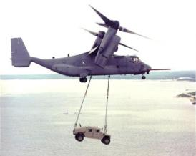
Figure 1 - V-22 Osprey Tilt Rotor Aircraft (1)

Figure 1 above shows how one of the Osprey’s limitations is that it cannot land while carrying cargo; it would first have to release the cargo. Also shown are the very vulnerable rotors.

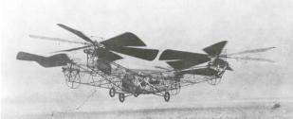
Figure 2 - De Bothezat Quad rotor 1923 (2)

In the early 1900’s when helicopters (5) were still in development, another type of aircraft was also in development, the Quad rotor (2). The quad rotor was abandoned due to difficulty controlling the craft until recently when electronic controls replace manual mechanical controls.

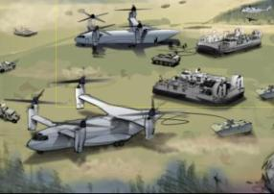
Figure 3 - Boeing Quad Tilt Rotor Aircraft (3) (6) (7)

Shown in figure 3 is the military’s new quad tilt rotor intended to compliment the V-22 Osprey. The new aircraft will likely become the new heavy cargo plane for the military. However it still has vulnerable rotors. (7) (3) (6)

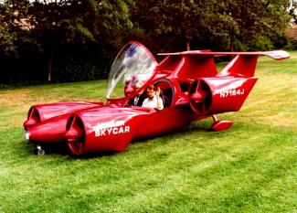
Figure 4 - Sky Car (4)

Figure 4 shows the modern day civilian version of a quad tilt rotor air craft that is being developed by Moller International. The primary reason it is not seen buzzing the skies is that the FAA is trying to figure out how to regulate the new aircraft (4).

Research ~ Probable Solution

The Pelican Drop Ship is a space craft from the video game Halo. According to Halo Wiki the Pelican measures 100 feet long, 77 feet wide and over 35 feet tall with the landing gear down (8).

In figures 5 and 6 below are some images of the Pelican. More images for reference are in Appendix A.

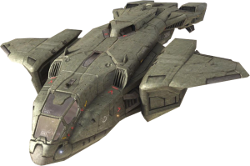
Figure 5 – Halo Pelican Drop Ship (8)

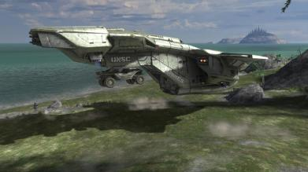
Figure 6 - Halo Pelican Carrying Vehicle (9)

As seen in the above figures the pelican is a vertical takeoff and landing aircraft that can carry cargo underneath the rear section with a compartment in the front for passengers. It features; four engine nacelles each with thrust nozzles pointing in both the downward direction and towards the rear, retractable landing gear, rear door, and some sort of cargo pick up mechanism.

There are several things that make the Pelican different from other similar types of air craft. The first thing is some sort of rocket propulsion system. The second is that the engine pods, also called nacelles, rotate or tilt and the left and right sides are independent from each other, unlike the V-22 Osprey (1), to assist in maneuvering the aircraft, much like thrust vectoring systems on the modern day F-25 (10) or the Harrier Jump Jet (11). The third difference is that the engine nacelles are enclosed, protecting the internal systems from external influences.

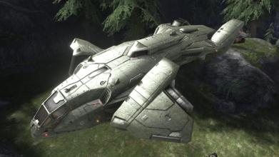
Figure 7 - Halo Pelican with Nacelles Rotated (9)

Figure 7 above is a screen capture from the video game Halo3 (9). The image shows that the left and right engine nacelles rotate independently from each other.

Research ~ Features of Prototype

A simple list of the features of the prototype based on the research shown in Appendix A
The following phrases can be completed with … is important to the prototype.

- Can Carry Troops and Cargo
- Can collapse into smaller storage size
- VTOL ( vertical take-off and landing)
- Supersonic Flight
- Radar Stealth
- Retractable Landing gear
- Easy for one person to fly
- Redundant Systems
- Easy to Assemble
- Low cost (<$5000)
- simple maintenance
- Reliable
- Safety
- Being Legal to fly in the USA
- Flight stability
- Indoor safe flight
- Programed easily
- Durability
- Long flight time (2-10 minutes)
- Cheap replacement parts
- Quiet (<65db)
- Easy to balance
- Easy to adjust
- A known scale ratio (size only)
- Can fly to predefined waypoints
- Can carry FPV camera sys
- A fast battery recharge time (approx. 1hr)
- Simplicity of preflight setup
- Similarity of appearance to Halo Pelican Drop-Ship (not exact)
- Fitting into a trunk fully assembled

The list above has several features that are simply unreasonable for a remote controlled prototype and will not be included in the final list of features. A refined list of features that this project will aim to accomplish is below. This list will become the prototype objectives, described later.

- Similarity of appearance to Halo Pelican Drop-Ship (not exact)
- VTOL ( vertical take-off and landing)
- Flight stability
- Low cost (<$5000)
- Safety
- Being Legal to fly in the USA
- Simplicity of preflight setup
- Fitting into a trunk fully assembled
- Indoor safe flight
- A known scale ratio (size only)
- Easy for one person to fly
- Cheap replacement parts
- Durability
- Easy to Assemble
- simple maintenance

Research ~ Customer Needs

In an interview with a fellow student that took place in January 2011 two major topics were discussed. The first was suggestions on where to start; he gave two suggestions. The second major topic was desired features; he wanted a total of six.
The first suggestion was to use a modified Quadra Copter. As in buy one and modify it as needed in order to first make it function like the pelican, titling nacelles that help maneuverability. And second, make it look similar to the pelican’s geometry. The second suggestion was to use an R/C auto pilot system from DIY Drones (12). James said it was easily modified and easily programed and expanded in capabilities.
There were six desired features discussed in the interview. James wants cargo carrying ability and retractable landing gear. James doesn’t think lights are necessary. James also wants the prototype to be able to fly indoors in an area such as a gymnasium or large cafeteria. Another thing James wants is to be able to be flown out side on a light breezy day. Lastly James wants the air craft to be small enough to fit into trunk when fully assembled. (13)

Research ~ Customer Needs - Survey

To find out what potential customers would want in a prototype aircraft a survey was distributed to potential customers. The Survey and its results are shown in Appendix C. Questions for the survey were derived from the research conducted. To summarize the results refer to the table below.

Table 1 – Survey Results Summary
Question | Average
VTOL ( vertical take-off and landing) | 5.00
Flight stability | 4.78
Easy for one person to fly | 4.56
Durability | 4.33
Simplicity of preflight setup | 4.22
Easy to Assemble and maintain | 4.22
Low cost | 3.89
Safety and Indoor safe flight | 3.89
Legal to fly in the USA | 3.67
Fitting into a trunk of midsize car, fully assembled | 3.67
Similarity of appearance to Halo Pelican Drop-Ship (not exact) | 3.44
A known scale ratio (size only) | 2.89
Inexpensive replacement parts | 2.78

As shown in table 1 above there were only nine responses to the survey. Of the questions asked, the potential customers found that question number two was most important with an average rating of 5 out of 5. The least important based on the average response was question eleven. Question number two asks how important vertical takeoff and landing is to the prototype. And question eleven asks how important it is to have inexpensive replacement parts.

Prototype Objectives

It is important to define a set of goals that the prototype will meet by the end of the project, also known as prototype objectives. These objectives are what will determine if the project is a success or not.

Prototype Objectives ~ Engineering Characteristics of Prototype

Here is a list of the engineering characteristics that will be used later in the design phase of the project for decision making.

- geometry
- mass to thrust ratio
- center of gravity location near center of geometry
- electronic controller gain settings
- material strength
- material density
- total cost (<$5,000)
- # of items on preflight check list
- Known Scale Ratio
- maintains horizon plane (+/- 10 degrees)
- mechanical safety factor
- single person
- control scheme
- material choice (no fabric / no heat shrink)
- standard tooling
- oversized access ports
- solder free wire harness design
- power switch
- no toxic fumes during operation
- engine nacelles tilt
- one or more options (landing gear, rear door, cargo pick-up)
- FAA / AMA / FCC / …

Each of the above can be tested or proven in some way. More research for FAA, AMA and FCC regulations must be done at the beginning of the design phase and will help with component selection and other decisions that need to be made during that time.

Prototype Objectives ~ Decision Making Technique - QFD

The above features list and their weights from the survey are combined with the list of engineering characteristics to form a decision making tool known as a QFD. Below is the QFD for this project, it shows lots of useful information.

Table 2 - QFD

In the center of table 2 is a relationship matrix showing how each of the features and characteristics relate to each other. At the bottom of the table is the relative and absolute importance of each engineering characteristic, these values can be used in the selection process for components and configurations during the design phase. At the right of the relationship matrix are importance weights for each of the features determined by taking the average response from each question on the survey, and multiplying by a designer’s importance factor. A larger image of the table is available in Appendix D.

Prototype Objectives ~ In Order of Importance

This is a list of product objectives and the method for measuring or obtaining them. Each item is listed in order of relative importance, as found by the survey. This weighted list could be used as a grading rubric of sorts for the final prototype.

- (11%)VTOL ( vertical take-off and landing)
- (10%)Flight stability
  - maintains horizon plane +/- 10 degrees in straight level flight and hover in still air environment
  - Does not drift in hover along horizon plane more than typical small RC helicopter
- (10%)Easy for one person to fly
  - First time flyer after 1 hr. or less of practice
  - can see orientation at a distance
  - Similar control scheme to other RC aircraft
- (10%)Durability
  - Can withstand mild bumps into wall Impact velocity at least 10% maximum
    - Calculated, based on mass, battery time, forward thrust capacity
  - Can withstand drops from height
    - Drop height at least 0.5meter
      - Calculated via FEA
- (9%)Fits into a trunk fully assembled
  - midsize car such as Honda Civic
- (8%)Similarity of appearance to the Halo Pelican Drop-Ship (not exact)
  - The Geometry silhouette and features of the aircraft matches the silhouette of the pelican (minus small or sharp features such as decorative fins or vents or lights)
    - Exterior features only
    - interior features will be attempted but not required due to time constraints
    - engine nacelles may not match due to flight dynamics
    - Engine nacelles tilt to assist maneuvering the aircraft
  - Fuselage has enclosed area for troops and external cargo suspension area
    - Interior “troop” area may be left used for RC equipment
  - One or more of the following three, depends on total mass of system and number of channels available on RC system:
    - Landing gear Two main with one front wheel (all retractable, and support aircraft and maximum payload)
    - Rear door / ramp Opens and closes allowing access to interior of aircraft May be access port to RC equipment
    - Cargo Pick up mechanism
      - Picks up and secures cargo
      - can release without manual intervention

- (8%)Easy to Assemble and simple maintenance
  - One person
  - no fabric or heat shrink needed
  - Standard tooling if any
  - Oversized access ports where needed / possible
  - Solder free wire harnesses
    - Designed to be in kit form
- (7%)Low cost
  - Less than $5,000 for a Prototype
- (7%)Simplicity of preflight setup
  - Short check list (less than 10)
  - Single person
- (6%)A known scale ratio (size only)
- (5%)Inexpensive replacement parts less than $50.00 each
- (5%)Safety and indoor safe flight
  - Guards where possible
  - Dangers marked clearly (hot, sharp, voltage, …)
  - An appropriate mechanical design safety factor
  - Power switch
  - Wired using safe plugs and properly insulated
  - Removable parts secured (not loose)
  - No toxic fumes during operation
  - No cuts to wall or furniture (abrasions may still occur)
  - Will not cut skin
  - Glass or other fragile objects may still be damaged
- (4%)Legal to fly in the USA
  - AMA regulations met (amateur model aircraft) (yes or no)
  - FAA (yes / no)
  - FCC / UL? / CE? / (radio transitions) / (remote controlled aircraft) / (UAV?) May not apply (yes / no)

Design

Design ~ Objectives

Below is a list of six prototype design objectives selected based on the prototype objectives that were discussed above. Due to scheduling and budgeting constraints these six objectives are what the prototype will be required to meet. If any one of the objectives cannot be met, there must be an explanation and or possible methods of reaching that goal.

- Similarity of appearance to the Halo Pelican Drop-Ship (not exact)
  - The Geometry silhouette and features of the aircraft matches the silhouette of the pelican (minus small or sharp features such as decorative fins or vents or lights)
    - Exterior features only
    - engine nacelles may not match due to flight dynamics and airflow
    - Engine nacelles tilt to assist maneuvering the aircraft
- VTOL ( vertical take-off and landing)
- Low cost
  - Less than $5,000 for a Prototype
- Fits into a trunk fully assembled
  - midsize car such as Honda Civic
- Durability
  - Can withstand drops from height
    - Drop height at least 0.5meter
      - Calculated via FEA
- Easy to Assemble and simple maintenance
  - One person
  - no fabric or heat shrink needed
  - Standard tooling if any
  - Oversized access ports where needed / possible
  - Solder free wire harnesses
    - Designed to be in kit form

Design ~ Alternatives and Selection

  - 1/48 scale
    - Nacelle good for 1+1 raw open ducted fan
      - Bad for appearance
      - Good for budget
      - Thrust?
    - Fuselage good size for nacelle configuration 1+1
  - 1/32 scale
    - Nacelle good for 1x2+2 closed configuration
      - Assuming airflow is acceptable
      - Thrust?
    - Fuselage good size for nacelle configuration 1x2+2
  - 1/22 scale
    - Nacelle good for 2x2+2 closed configuration
      - Assuming airflow is acceptable
      - Thrust?
    - Fuselage good size for nacelle configuration 2x2+2
- Nacelle configurations example
  - 1x2 using 55mm ducted fan
  - …+# using 30mm ducted fan
- Vehicle mass estimated bases on fractional volume of “box” for that particular scale
  - 1% by volume for main material
  - Box volume = overall length * overall width* overall height
- Only some alternatives used in matrix to keep it simple
  - Not all possible alternatives represented
    - The ones removed were definite “will not work”
- Only done for maximum size that fits into trunk
  - 1/22 scale
  - Only done with 55mm ducted fans for lift
    - Other sizes not practical

Design ~ Component Selection

Forward motion ducted fans were selected based on smallest available size and needed ESC and batteries determined from there

Lift fans determined by alternative selection matrix and (thrust to weight) and Cost and motor size availability

Also nacelle configuration, maximum scale that fits into car trunk, and similarity of appearance to the halo pelican, played a role on eliminating fans larger than 55 mm.

Table 3 – Fan Selection (14)
 | fan info |  |  |  |  | Battrey Mass | ESC
item | fan dia | thrust | mass | current | cost per unit | aprox mass | cost | mass | cost
 | mm | grams | grams | amps | $ | grams | $ | grams | $
1 | 30 | 130 | 16 | 13 | 24 | 100 | 10 | 19 | 15
2 | 30 | 200 | 18 | 20 | 26 | 80 | 8 | 22 | 20
3 | 55 | 470 | 70 | 18 | 17.4 | 150 | 14 | 35 | 30
4 | 55 | 540 | 70 | 30 | 22.7 | 170 | 20 | 35 | 30
5 | 90 | 3000 | 550 | 85 | 140 | 565 | 50 | 112 | 160
6 | 90 | 3200 | 550 | 65 | 140 | 620 | 70 | 112 | 160
 | indicates best options for lift fans and forward fans

Servos selected after iterative analysis of geometry. The decision was based on size and torque needed
The final servo selected is as follows:

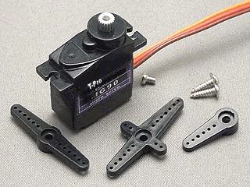
Figure 8 - T-Pro 9gram Servo (14)

Weight: 14g
Dimension: 23*12.2*29mm
Stall torque: 2.2kg/cm(4.8V )2.5kg/cm(6V)
Operating speed: 0.11sec/60degree(4.8v), 0.10sec/60degree(6v)
Operating voltage: 4.8-6.0V

Design ~ Controller Needs and Selection

R/C channel distributions / general mixing
- # of output channels needed = 8 minimum, 10 preferred
  - 6 channels for ducted fans
    - 4 for downward engine thrust
    - 2 for aft thrust ( left / right)
  - 1 for landing gear (optional)
  - 1 for rear door (optional)
  - 2 for nacelle servos (left right)
- # of input channels = 5 minimum, 8 preferred
  - 1 channel for throttle
  - 1 for left / right spin
  - 1 for forward / backward / tilt up / down
  - 1 for roll left / right
  - 1 mode selection
  - 1 landing gear (optional)
  - 1 rear door (optional)
  - 1 pick-up mechanism (optional)

Figure 9 – Diagram of controller unit hooked up to R/C components for new aircraft

Figure 9 illustrates the proposed microcontroller system being added between the receiver and speed controllers and servos. The landing gear servo is optional and is not connected to the micro controller because it doesn’t need to be. There are six and even nine channel transmitter / receivers available, however they still don’t allow for the complex channel mixing that is required for the hybrid aircraft.

Table 4 – R/C channel distribution for new aircraft with microcontroller unit
Channel Input from Transmitter | Channel output from Receiver | Input to Microcontroller Unit | Output from Microcontroller Unit | Servo / Motor Channel
Throttle | Throttle | Throttle | Throttle front right | Throttle front right
Roll | Roll | Roll | Throttle front left | Throttle front left
Pitch | Pitch | Pitch | Throttle right rear | Throttle right rear
Yaw | yaw | yaw | Throttle left rear | Throttle left rear
Flight Mode | Flight mode | Flight mode | Throttle forward flight Left | Throttle forward flight Left
Landing Gear  (Optional) | Landing gear  (goes direct to servo) |  | Throttle forward flight Right | Throttle forward flight Right
 |  |  | Left servo | Left servo
 |  |  | Right servo | Right servo
 |  |  |  | Landing gear

As shown in Table 4, with the addition of a microcontroller it may be possible to expand the functionality of R/C transmitter receiver systems such that more than the standard amount of channels can be mixed and even added to the output of the receiver.

The controller selected is shown in Appendix B. It is the ArduPilot Mega. It features eight inputs and eight outputs. With the ability to be programed such that the channels can be mixed in any way desired. It also has support for wireless telemetry, which will come in handy while testing the prototype, by providing acceleration and other onboard sensor data.

Design ~ Analysis

The analysis of the design was broken into two methods, Finite Element Analysis and Physical Testing. The finite element analysis was for the mechanical stress and deflection. The physical testing was to confirm the thrust produces by the selected fans would not be restricted by the body of the nacelle.

Design ~ Analysis – Loading Conditions

The loading conditions vary depending on the analysis being conducted. Four different loading condition sets; one for being on the ground in a un-powered state, one for maximum upward vertical acceleration, another for simple impact from 0.5 meter drop onto all three of the landing gear struts, and finally the thrust produced by the ducted fans.

On the ground the force of gravity is the only force acting on the prototype. The reaction forces on the landing gear counter act the force of gravity. Appendix J has tables and images illustrating the locations directions and magnitudes of each force.

As the vehicle accelerates upward the supports are located at the fans and the force acting on the prototype is an equivalent gravitational force. Appendix J shows the location and direction of the forces.

Impact is almost identical to being on the ground. The only difference is the magnitude of the gravitational force. Images of the locations and directions of forces and supports are in Appendix J.

Design ~ Analysis – Airflow Testing

In order to ensure that the engine nacelles don’t restrict air flow, a physical measurement of the output thrust had to be made. This was done by assembling a test nacelle and measuring the output force. As shown in Appendix P, there were two tests conducted. The first test, shown in figure 10 bellow, was with a nacelle that was very close in appearance to the Halo Pelican. However the test failed due to lack of air flow. The second test was with the same nacelle prototype; however it was modified to allow more air to flow through the system.

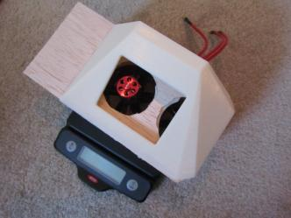
Figure 10 - First Nacelle Air Flow Test

Table 5 – Airflow Test Results Summary
Variant | Lift Force | Needed Lift Force | Pass / Fail
Initial “Best Appearance | 0.78 Newtons | 7.85 Newtons | Fail
Final Open Flow Design | 7.85 |  | pass

Table 5 above show the results of both tests. It also shows the needed lift force from the nacelle.

Design ~ Analysis – Calculations

As shown in detain in Appendix M, the calculations for this project were not complex, however they were done repeatedly. The most used formula was f=ma, in its basic form. This was used to determine whether or not the prototype would lift off. The initial estimate for vehicle mass was only off by approximately 10%.

Impact calculations were done in two parts, both are estimates based on several assumptions. The first assumption is that when the prototype “crashes”, it will do so onto all three landing gear struts equally. Second, the prototype will stick to the hard ground and not bounce or slide or pivot. And finally the assumed worst case is that it will crash with no power to the servos, eliminating any damping effects they might have. The first impact estimate was based on an impact time chosen arbitrarily. The second impact estimate was based on maximum deflection. This occurs at the front nacelles, and has a value equal to the distance from the pivot point on the nacelle to the farthest rear edge divided by two for range of motion limits, shown below in Figure 11.

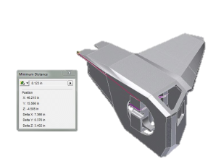
Figure 11 - Maximum Deflection at Front Nacelle

Some impact calculation notes;
1) Maximum Deflection in entire assembly is @ front nacelle rotating "freely" (un-powered state) divided by 2 for range of motion limit
2) FEA Calculates as non-mechanism; FEA deflection not true
3) Landing gear is only part that fails, could be reinforced easily

Also in Appendix M, are the results from confirming that the selected servos have enough torque to move the nacelles and withstand impact without damaging the motor. The test was performed in Inventor with a gravity force equal to the 5g impact force estimated earlier. The maximum servo toque of 1.5lb-inches was used. It was found that at the maximum torque of the servos selected, the nacelles would not be forced downwards by the impact, in a powered state. This means that in the event of an impact the servo motors will not be damaged, and that the servos have enough torque to rotate the nacelles during normal flight.

Design ~ Analysis – Results

The results of the analysis, with the exception of the impact results, show that the prototype will be able to take off and maneuver in the intended manner without falling apart.

Some statistics of the analyzed prototype are shown in the table below and the reports generated by the Autodesk Inventor software that performed the F.E.A are shown in Appendix J. While the analysis does not include all possible loading conditions, it does include the worst case of the conditions that the prototype was being designed for. With the exception of the impact analysis, all of the results show that the prototype will be successful in its flights.

Table 6 – Results Design Analysis Summary
 | Units | Value
Mass of Prototype | Pound Mass | 6.36
Volume | Cubic Inches | 1013.5
Maximum Vertical Acceleration Upwards | G’s | 0.3
Maximum Safety Factor | N / A | 15
Minimum Safety Factor | N / A | 0.58
Maximum Displacement | Inches | 1.52

Design ~ Analysis – Results - Factors of Safety of Concern

There is only one factor of safety that is concerning, and that is for the impact analysis. The lowest safety factor of 0.58 is located at the bottoms of the landing gear struts as shown in Figure 12 below. In future development a damping system could be added to reduce the stress at these points, however for prototype version 1.0; this issue will not be addressed. As the second lowest safety factor is 1.25, again at the landing gear in impact. Larger images and tables of results are located in Appendix J.

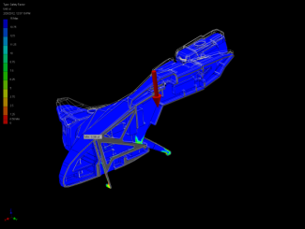
Figure 12 - Worst Case Safety Factor

Manufactureing

Fabrication

Three different techniques were used in the manufacturing of parts for the prototype; CNC Milling, laser cutting, and 3D Printed Plastic. The original plan was to have several parts CNC milled out of balsa wood and Styrofoam. However, due to material procurement issues and the length of time needed for DAPP to machine a large number of the prototype parts. Several figures below show the various examples for each type of manufacturing process used.

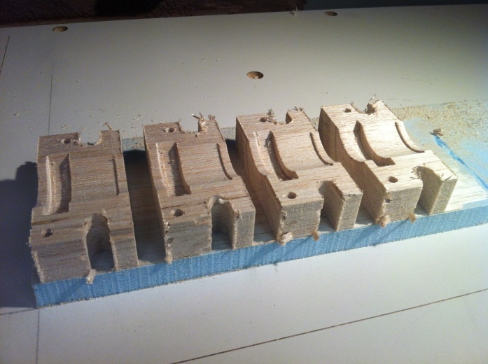
Figure 13 - Ducted Fan Mount Blocks Being Machined

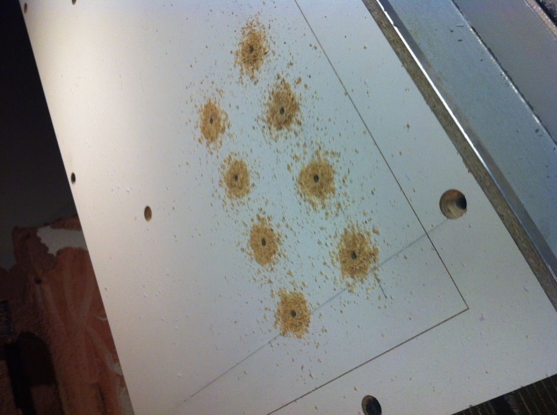
Figure 14 - Pin Holes for Machining Mount Blocks

Figure 13 - Ducted Fan Mount Blocks Being Machined and Figure 14 - Pin Holes for Machining Mount Blocks, both figures show the first and second steps respectively of machining the ducted fan mount blocks out of balsa wood. It started with a 4x4x12 inch block of balsa wood that was glued to a sheet of blue foam which was tapped to the mount surface using double sided tape. Once the first half of the cut was complete the now 4 smaller blocks were removed from the foam and placed onto pegs, the holes for which were drilled into the mount surface by the machine. The final product is shown later in Figure 18 - Nacelle Sub-Assembly.

Figure 15 shown below, is an image of the center triangular support that goes in the front section of the prototype. This part along with more than a dozen others was cut out of balsa wood using DAPP’s laser cutting service. Parts like this serve as the frame of the aircraft.

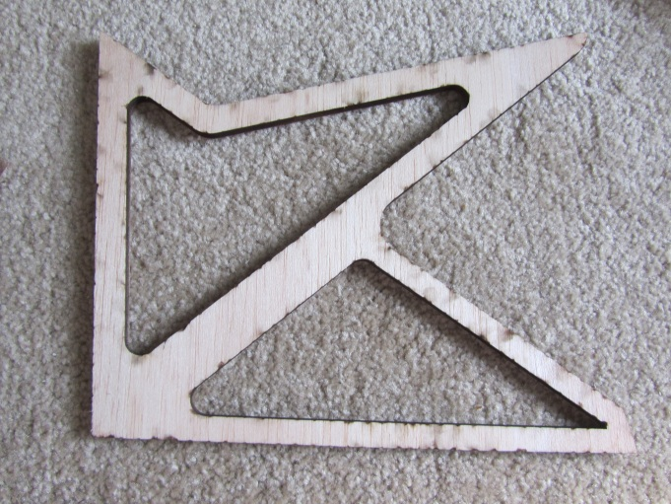
Figure 15 - Center Triangular Support Example of Laser Cut Part

Figure 16 shows the 3d printed white ABS plastic nacelle bearing tubes. These are used to support the front nacelles, allowing them to rotate for aircraft maneuverability. There are two large ones in the front and two smaller ones in the back, size was determined for esthetics and verified for strength using FEA.

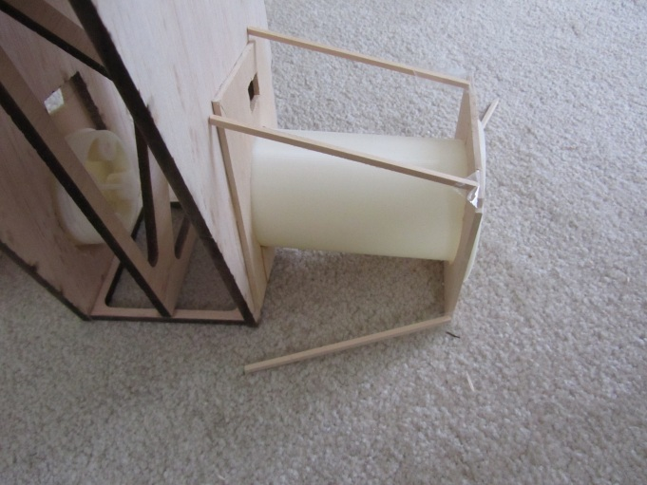
Figure 16 - Plastic Nacelle Bearing Tube 3D Printed

Assembly

Originally, Assembly was to take place in halves; left and right. However, without the CNC Milled foam parts and some balsa parts, the frame had to be assembled front to back. Using a small steel plate and some rare earth magnets the first three parts were glued together with epoxy, as shown in Figure 17.

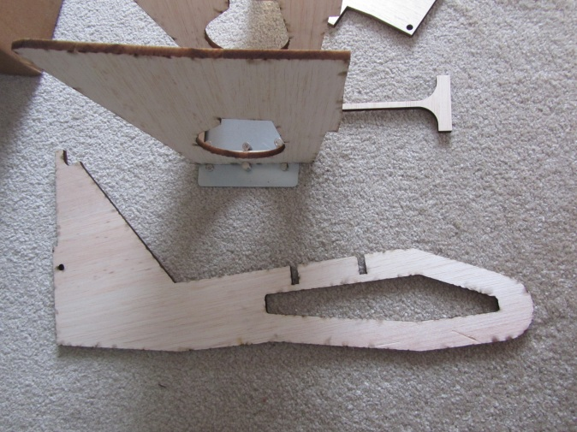
Figure 17 - Laser Cut Frame Parts Being Glued with Magnetic Clamp

The rear nacelle subassembly without the outer foam enclosure is shown in Figure 18. Each nacelle consists of two 55 mm ducted fans for lift and one 30mm ducted fan for moving forward. The subassembly is made of one laser cut part glued to one of the CNC milled fan mount blocks.

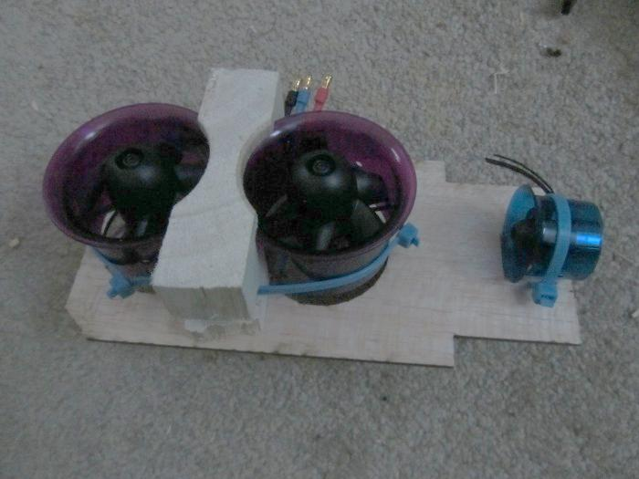
Figure 18 - Nacelle Sub-Assembly

The full assembly is not yet complete, and some hand made parts were used to attempt to make the prototype flyable. Shown in Figure 19 and Figure 20 is the current state of the prototype. Figure 20 shows a close up of the main controller unit and the receiver, both of which are connected such that if working properly would enable the prototype to fly.

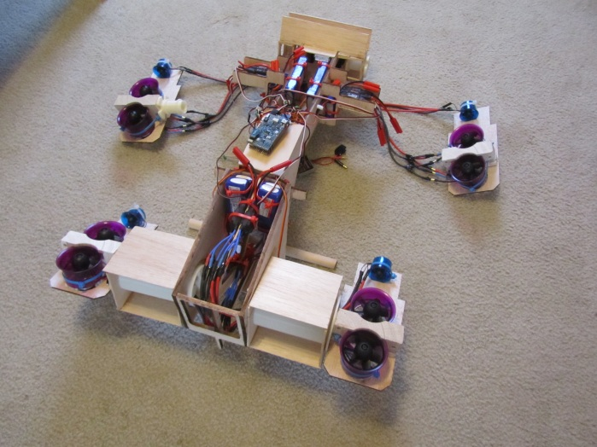
Figure 19 - Current Full Assembly

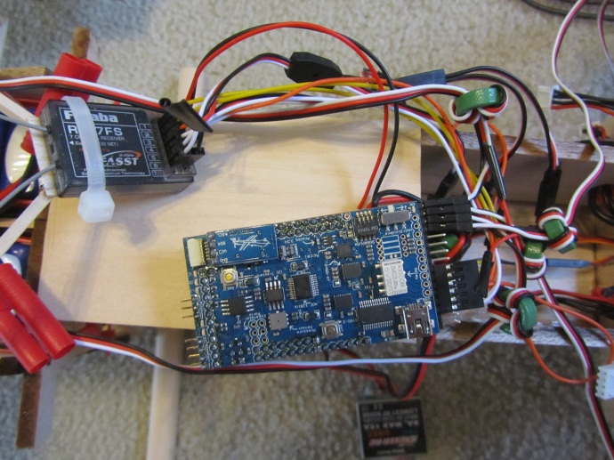
Figure 20 - Close up of Controller and Receiver

Proof of Design

Testing Methods

Testing of the controller could only have occurred once there was a frame of some sort to mount the motors and other electronics to. After connecting the controller to a computer via USB cable, programing it, then powering up for a test take off, it was found to be non- functional. The cause has yet to be determined.

Tests of servos in the front also proved to be problematic. Shown in Figure 21 is the front nacelle servo linkage prior to the test. The test was simply using the transmitter and receiver to move one of the servos, to ensure that there is enough torque and range of motion.

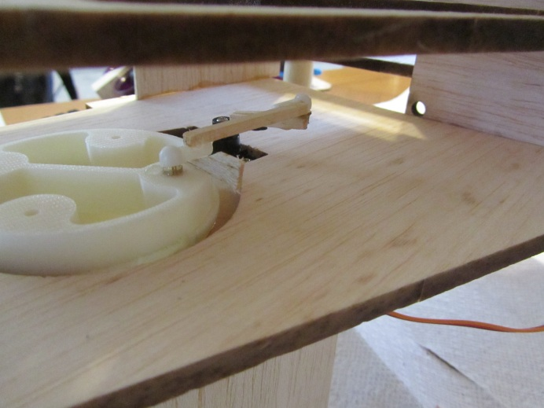
Figure 21 - Servo Linkage Front Nacelle

Testing Results

The following table shows the results of each test that was to validate the design of the prototype. The last three tests were not yet performed due to failures in the first two tests.

Table 7 – Test Results
Test # | Test of | Result | Notes
1 | Controller | Fail | Cause is Unknown
2 | Servos | Fail front and Pass Rear | See Below
3 | Air-Flow | Pass | -
4 | Lift-Off | Unknown | Test not yet performed
5 | Forward Flight | Unknown | Test not yet performed
6 | Nacelle Maneuvering | Unknown | Test not yet performed

In Table 7 the servos test has a double result; fail and pass, which is a contradiction. This is simply saying that the front nacelle servo test failed and the rear servo test passed. The front servo test failed due to lack of glue adhesion between the servo arm and the linkage between the arm and bearing tube. Also due to the hand-made supports of the front nacelle bearing tubes there was too much friction to be overcome by the servo. The Rear servo passed because it was directly connected to the servo arm; no mechanism in-between.

PROJECT MANAGEMENT

The project will be managed in two ways, economically and by time. In order to manage the project by time, an estimated schedule must be formed. And to manage the project economically a proposed budget must be formed. By utilizing both it is hoped that the project can be completed wit in a reasonable time span and without breaking any bank accounts.

Budget ~ Proposed

Appendix F shows table 7 with additional columns for the actual cost information for comparison at the end of the project to help determine how well the project was managed economically. Also in Appendix B, there are several examples of possible components.

Table 8 – Forecasted Prototype Budget
Component / Materials | Forecasted Quantity | Total Forecasted Amount $
Receiver / Transmitter | 1 | 300
Servos | 5+ | 100
Computer Controller | 1 | 500
Batteries | 8+ | 240
Wire / Connectors / Switches |  | 90
Motors / Ducted Fans | 16+ | 480
Electronic Speed Controllers | 8+ | 240
Hardware |  | 150
Bass / Balsa Wood |  | 400
Foam Parts |  | 2000
Telemetry System (testing) | 1 | 220
Miscellaneous | < 6% | 280
Total |  | $5,000

In table 7 above there is a preliminary list of components and features, along with their estimated quantities and costs. All of the data, with the exception of the foam parts and miscellaneous, is based on the preliminary concepts and component research. The foam parts are an allowable cost based on the chosen total project cost of $5,000. Everything was added up and the remaining funds were distributed between the foam parts and miscellaneous, which was kept at less than 6 percent of the total.

Schedule

As shown in Appendix E, all of the design will take place during winter quarter. Manufacturing and testing will take place spring quarter. At the end of spring there will be some time to fix any unforeseen issues. Below are some project milestone dates.

Table 9 – Project Milestones
Task | Estimated Duration | Date to be Completed | Actual Date Completed | Actual Duration
All 3d Modeling of major components in multiple scales | 6 Weeks  Approx. 90 Hrs. | Dec 19 2011 | Jan 6, 2012 | 11 Hrs
Initial FEA Calculations | 2 weeks  Approx. 40 Hrs. | January 2 2012 | N/ A | N/A
Component Selection | 3 weeks  Approx. 48 Hrs. | January 16 2012 | Jan 6, 2012 | 18 Hrs
Final Prototype Scale Choice | 1 Weeks  Approx. 16 Hrs. | January 23 2012 | Jan 6, 2012 | 6 Hrs
Final Scale Model & Analysis and Tweaking | 4 Weeks  Approx. 76 Hrs. | February 13 2012 | Feb 24, 2012 | 100 Hrs
DESIGN FREEZE | N/A | February 20 2012 | Feb 24, 2012 | N/A
Order Parts | N/A | February 27 2012 | Feb 27, 2012 | N/A
Assembly and First Test | 4 Weeks  Approx. 48 Hrs. | April 26 2012
Demo to Faculty | N/A | May 18 2012

Table 8 above shows; six project milestones, the estimated duration of each set of tasks, and the desired completion date. The estimated duration shown in the middle column is based on the number of hours of labor, and for example does not include glue drying time for assembly. Also each work week is limited to 20 hours of labor.

References
1. Hightech-Edge. [Online] Aug 3, 2007. http://www.hightech-edge.com/v-22-osprey-vstol-aircraft/817/.
2. Quadra Copter. Wkipedia. [Online] http://en.wikipedia.org/wiki/Quadrotor.
3. Boeing Quad Tilt Rotor. Wikipedia. [Online] http://en.wikipedia.org/wiki/Bell_Boeing_Quad_TiltRotor.
4. Sky Car. Moller International. [Online] http://www.moller.com/.
5. Helicopter. Wikipedia. [Online] http://en.wikipedia.org/wiki/Helicopter.
6. Global Security. [Online] http://www.globalsecurity.org/military/systems/aircraft/qtr.htm.
7. Areo News. [Online] http://www.aero-news.net/index.cfm?do=main.textpost&id=82a6fd0d-af70-4dfd-a173-bb3f1ac52a57.
8. Halo Wiki. [Online] http://halo.wikia.com/wiki/D77H-TCI_Pelican.
9. Bungie. Halo 3. [Video Game] s.l. : Microsoft, 2007.
10. Wikipedia. Lockheed Martin F-35 Lightning II. [Online] http://en.wikipedia.org/wiki/Lockheed_Martin_F-35_Lightning_II.
11. Wikipedia. Harrier Jump Jet. [Online] http://en.wikipedia.org/wiki/Harrier_Jump_Jet.
12. DIY Drones. [Online] http://diydrones.com/.
13. Rodgers, James. [interv.] Max Oltersdorf. Jan. 2011.
14. HobbyPartz. [Online] www.hobbypartz.com.

appendix a – Research Similar Air Craft

V-22 Osprey  Posted on Aug 3, 2007  in 800HighTech, Featured Articles, Military News, Video http://www.hightech-edge.com/v-22-osprey-vstol-aircraft/817/  Osprey carrying Humvee  Accessed Aug 2011    “The Osprey is a tilt rotor vertical/short take off and landing (VSTOL) multi-mission aircraft with capabilities like no other. Combining the vertical flight capabilities of a helicopter with the speed and range of a turbo prop airplane”  External Dimensions  - Length, fuselage, ft/m — 57.33/17.48  - Length, stowed, ft/m — 62.58/19.08  - Width, rotors turning, ft/m — 83.33/25.55  - Width, stowed, ft /m — 18.42/5.61  - Width, horizontal stabilizer, ft/m — 18.42/5.61  - Height, nacelles fully vertical, ft/m — 21.76/6.63  - Height, vertical stabilizer, ft/m — 17.65/5.38 | Noted Features  - VSTOL  - Wings and engines fold into smaller storage size  - Carries troops and or cargo  Noted Negative Features  - Can’t land conventionally due to large prop diameter, must have rotors tilted  - External cargo hangs below aircraft  - Foreseeable Low altitude flying issues  - Cant land without first “dropping” cargo

Harrier Jump Jet  http://en.wikipedia.org/wiki/Harrier_Jump_Jet  Harrier Jump Jet  Accessed Aug 2011  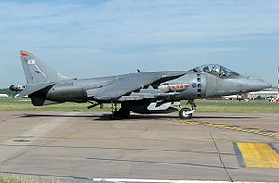  “The Harrier Jump Jet, capable of taking off vertically, can only do so at less than its maximum weight. In most cases the aircraft does a short take off where it gains forward speed and thus aerodynamic lift, saving fuel.  On aircraft carriers a ramp is frequently employed at the end of the carrier which allows the aircraft to accelerate along the carrier and then use a lower amount of fuel to take to the air.  Landings are also typically performed very differently. Although a conventional landing is possible, the range of speeds that this can be done over is narrow (due to relatively vulnerable outrigger undercarriage). Operationally the aircraft therefore usually does a near vertical landing with some forward speed.” | Noted Positive Features  - Short / Vertical Take-off and landing  - High speed 735mph  Noted Negative Features  - Vulnerable Outrigger landing gear  - Can only carry on board weapons

F-35  http://en.wikipedia.org/wiki/Lockheed_Martin_F-35_Lightning_II  F35 stealth supersonic STOVL fighter jet  Accessed Aug 2011  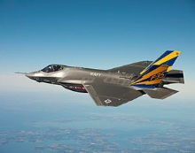  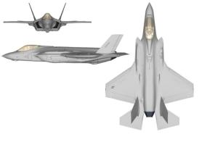  The F-35A is expected to match the F-16 in maneuverability and instantaneous and sustained high-g performance, and outperform it in stealth, payload, range on internal fuel, avionics, operational effectiveness, supportability, and survivability.[235] It is expected to match an F-16 that is carrying the usual external fuel tank in acceleration performance.[236] It also has an internal laser designator and infrared sensors, equivalent to the Sniper XR pod carried by the F-16, but built in to reduce radar cross section.  Unlike the other variants, because it can land vertically the F-35B has no landing hook. The "STOVL/HOOK" button in the cockpit initiates conversion instead of dropping the hook.[244] The F-35B sends jet thrust directly downwards during vertical takeoffs and landing and the nozzle is being redesigned to spread the output out in an oval rather than a small circle so as to limit damage to asphalt and ship decks.[245]  The United States Marine Corps plans to purchase 340 F-35Bs,[69] to replace all current inventories of the F/A-18 Hornet (A, B, C and D-models), and AV-8B Harrier II in the fighter, and attack roles.[246] | Noted Features  - Supersonic Flight  - Stealth  - Fighter Jet  - Replaces Harrier

Helicopter  Helicopter Wikipedia Article  http://en.wikipedia.org/wiki/Helicopter  Accessed Aug 2011  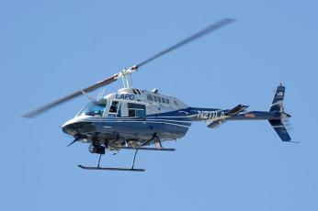  “A helicopter (informally known as a "chopper") is a type of rotorcraft in which lift and thrust are supplied by one or more engine-driven rotors. This allows the helicopter to take off and land vertically, to hover, and to fly forwards, backwards, and laterally. These attributes allow helicopters to be used in congested or isolated areas where fixed-wing aircraft would usually not be able to take off or land. The capability to efficiently hover for extended periods of time allows a helicopter to accomplish tasks that fixed-wing aircraft and other forms of vertical takeoff and landing aircraft cannot perform.” | Noted Features  - Efficient Hover for extended periods of time compared to other aircraft  - VTOL  Noted Disadvantages  - Limited forward flight speed  - Main Rotor at risk to damage

Quadra Copter  Quadra Copter Wikipedia Article  http://en.wikipedia.org/wiki/Quadrotor  Accessed Sept 2011  “A quadrotor, also called a quadrotor helicopter or quadrocopter, is an aircraft that is lifted and propelled by four rotors. Quadrotors are classified as rotorcraft, as opposed to fixed-wing aircraft, because their lift is derived from four rotors. They can also be classified as helicopters, though unlike standard helicopters, quadrotors use fixed-pitch blades, whose rotor pitch does not vary as the blades rotate. Control of vehicle motion can be achieved by varying the relative speed of each rotor to change the thrust and torque produced by each.  There are two generations of quadrotor designs. The first generation[when?] quadrotors were designed to carry one or more passengers. These vehicles were among the first successful heavier-than-air vertical take off and landing (VTOL) vehicles.[1] However, early prototypes suffered from poor performance,[1] and latter prototypes required too much pilot work load, due to poor stability augmentation.[2]  The more recent generation of quadrotors are commonly designed to be unmanned aerial vehicles (UAVs). These vehicles use an electronic control system and electronic sensors to stabilize the aircraft. With their small size and agile maneuverability, these quadrotors can be flown indoors as well as outdoors.[3][4]  The advantages of the current generation of quadrotors, versus comparably-scaled helicopters, are as follows. First, quadrotors do not require mechanical linkages to vary the rotor blade pitch angle as they spin. This simplifies the design and maintenance of the vehicle.[5] Second, the use of four rotors allows each individual rotor to have a smaller diameter than the equivalent helicopter rotor, allowing them to possess less kinetic energy during flight. This reduces the damage caused should the rotors hit anything. For small-scale UAVs, this makes the vehicles safer for close interaction. Some small-scale quadrotors have frames that enclose the rotors, permitting flights through more challenging environments, with lower risk of damaging the vehicle or its surroundings.[6]” | Noted Features  - Electronic stability controller  - Enclosable rotors

James Rogers Interview
Jan 2011
rogersj@mail.uc.edu
MET Student with interest in remote controlled UAV’S

Suggestions
- Suggested modified Quadra Copter
- Suggested using an RC Auto Pilot from DIY Drones for easily modified controlling method
Features Discussed
- Wants Cargo carrying ability
- Wants landing gear to be retractable
- Doesn’t care about lights
- Should be able to be flown in indoor area such as gymnasium or cafeteria
- Should be able to be flown out doors on light breezy days (10mph winds max)
- Should be compact enough to fit into trunk when fully assembled

DIY Drones Forum
Tilt rotor quadra copter
http://diydrones.com/forum/topics/tilt-rotor-quadcopter-for
Sept 2011

“The idea is to benefit from the stability and VTOL of the Quadcopter and the speed and efficiency of the airplane.”

Flight Simulation of Quad Tilt Rotor Aircraft
YouTube Link:
http://www.youtube.com/watch?v=4TiQIuZLF9Q&feature=player_embedded

Landing Gear Mechanism Example
YouTube Link: http://www.youtube.com/watch?v=E38G1VTpT64&feature=player_embedded

Halo Forum

Has anyone made a remote controlled pelican like aircraft before?



Only this Mega Blocks toy was found

http://halocollectors.com/?s=pelican&searchsubmit.x=0&searchsubmit.y=0
Aug 2011
A search for any remote controlled Halo Pelican Drop-Ship

http://halo.wikia.com/wiki/D77H-TCI_Pelican
Aug 2011
Halo Pelican Drop-Ship

Bottom three images taken from Video game “Halo 3”

Halo Pedia (Pelican Drop-Shop)


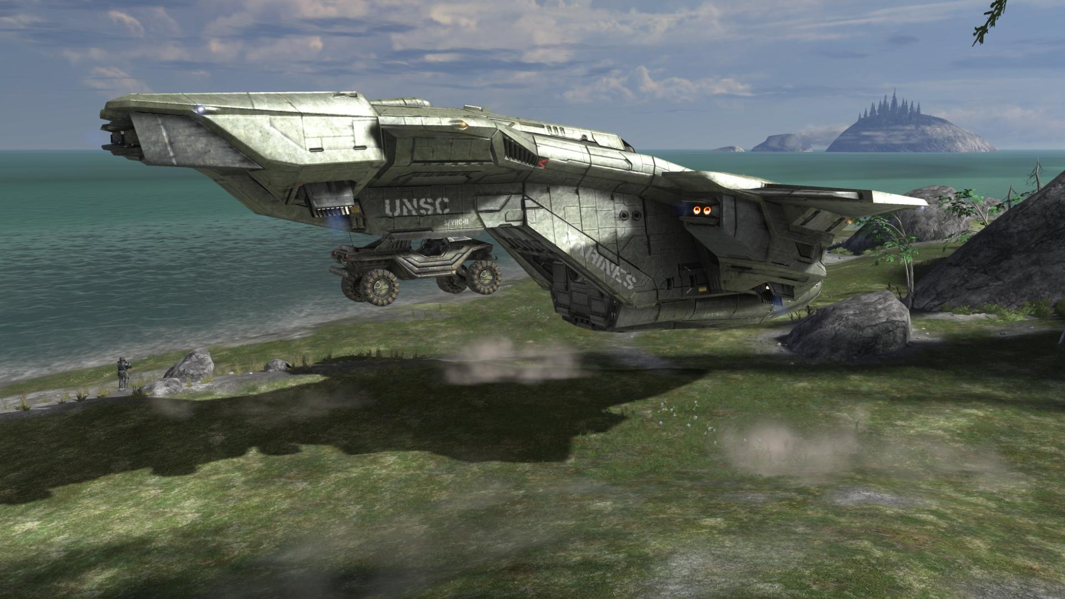
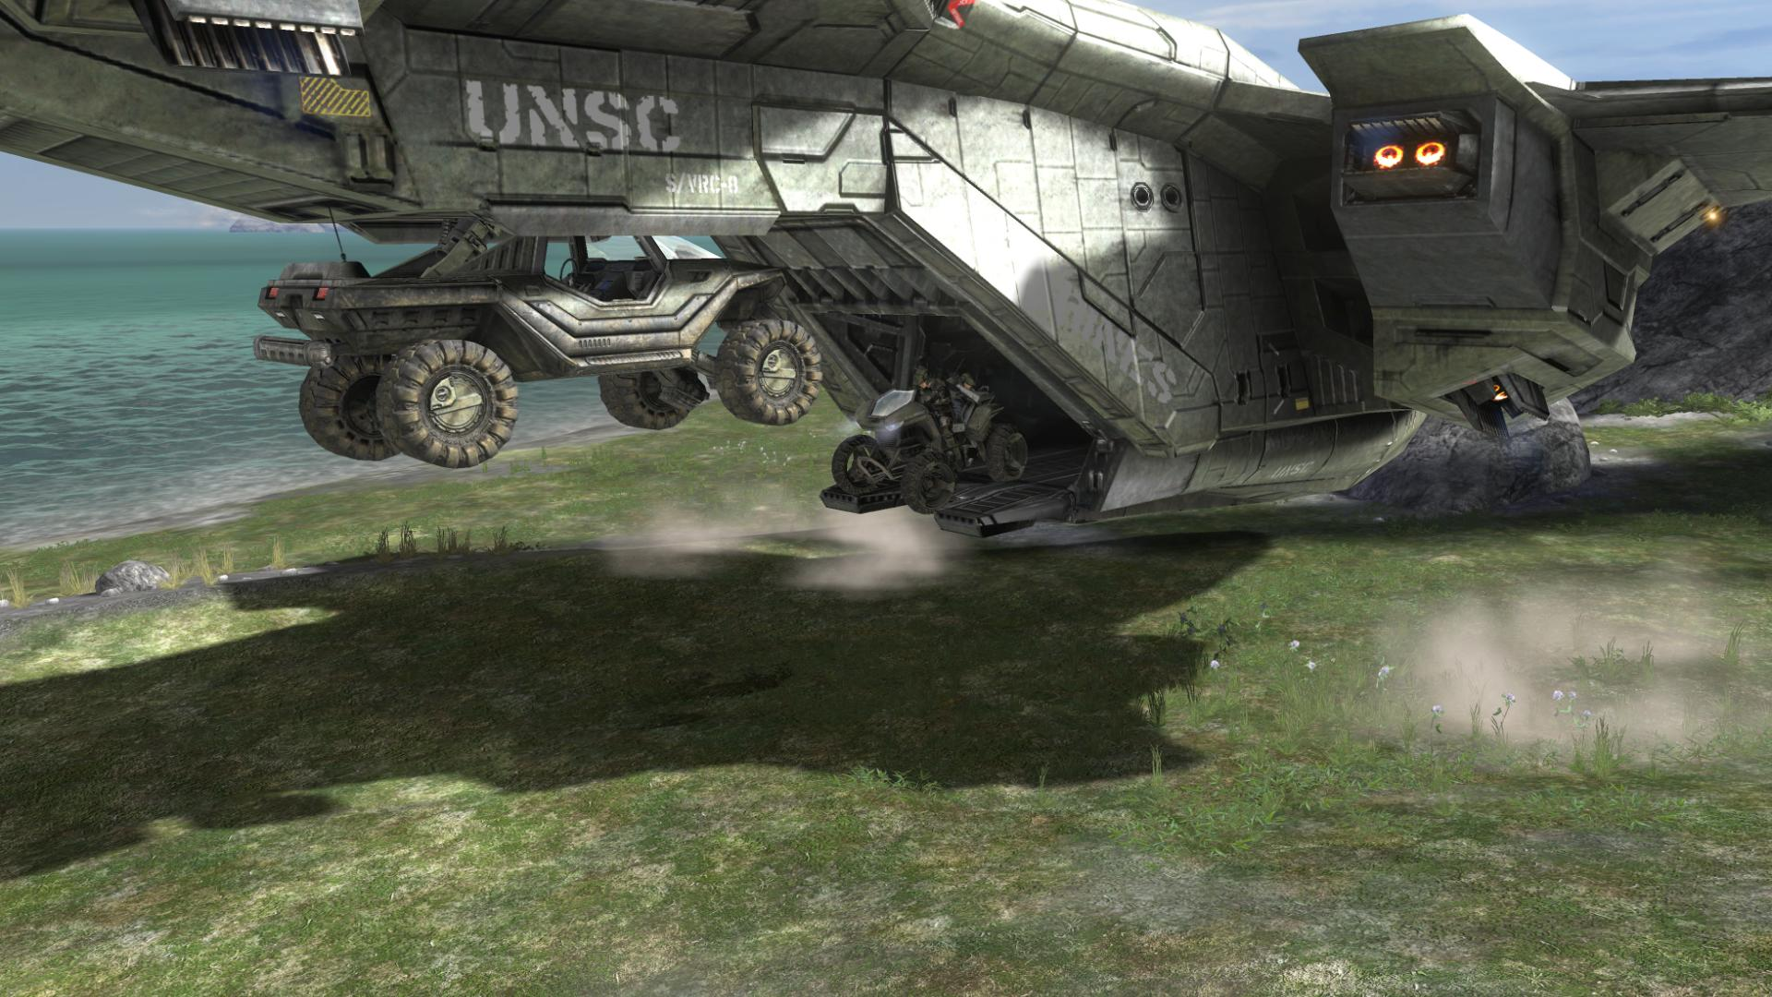
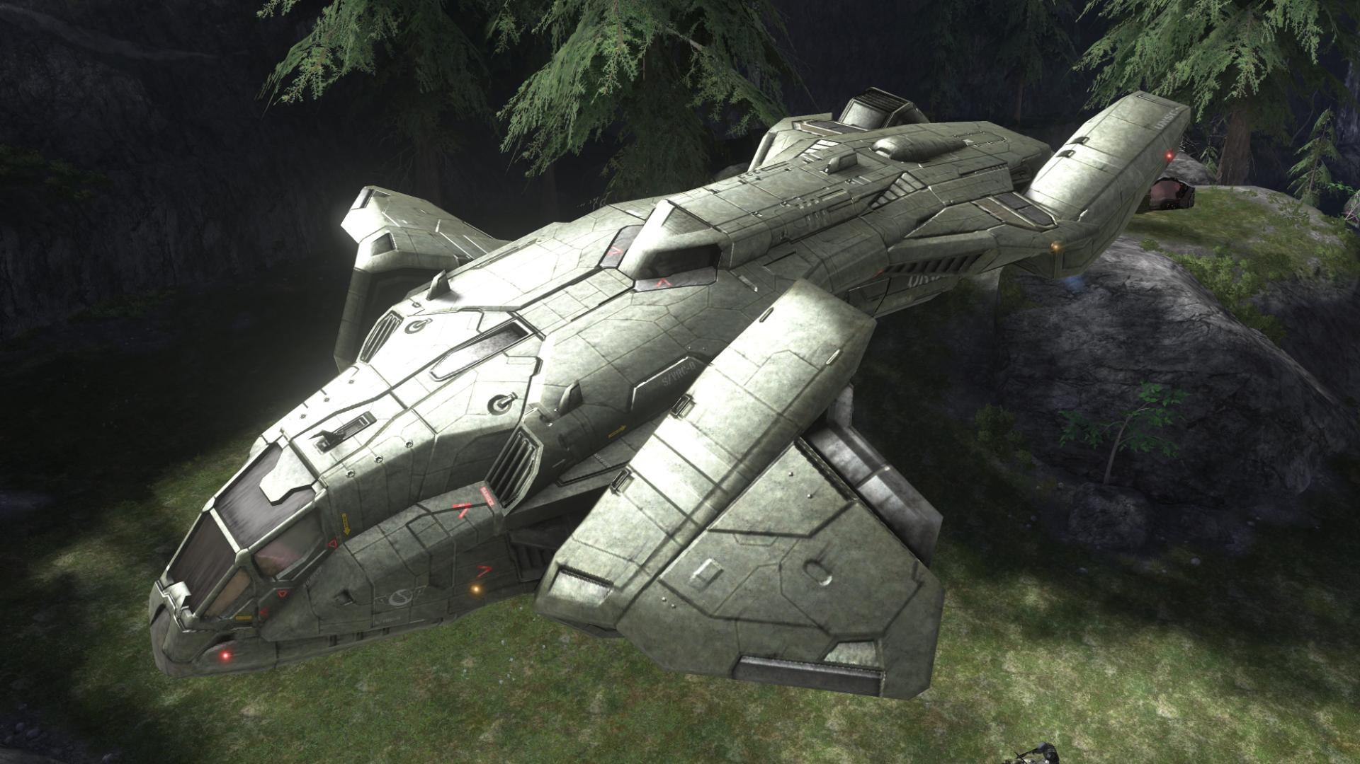

Noted Features
- VTOL
- Tilting Nacelles
- Troop Bay (10 seats)
- Cargo is carried under tail section
- Rear Door opens and closes
- Landing gear retracts flush with
- Armored / Enclosed Nacelles

RC Discuss Forum (features liked / disliked from other remote controlled aircraft)

Web page down for maintenance for several weeks
(Sept – Oct 2011)
- Can’t post to forum
- Can’t search previous posts

http://www.rcdiscuss.com/

Moller Sky Car  http://www.moller.com/  Sept 2011  Moller International  SKY CAR    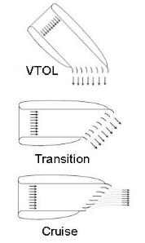 | Noted Features  - Easy to fly  - Soon to be Commercially available  - Redundant computer system  - Redundant engine system

Marty Lee Ball Interview
Student Game Designer from UK
Interviewed Jan 23 2011
Marty created replica 3d model of Halo Pelican Drop Ship

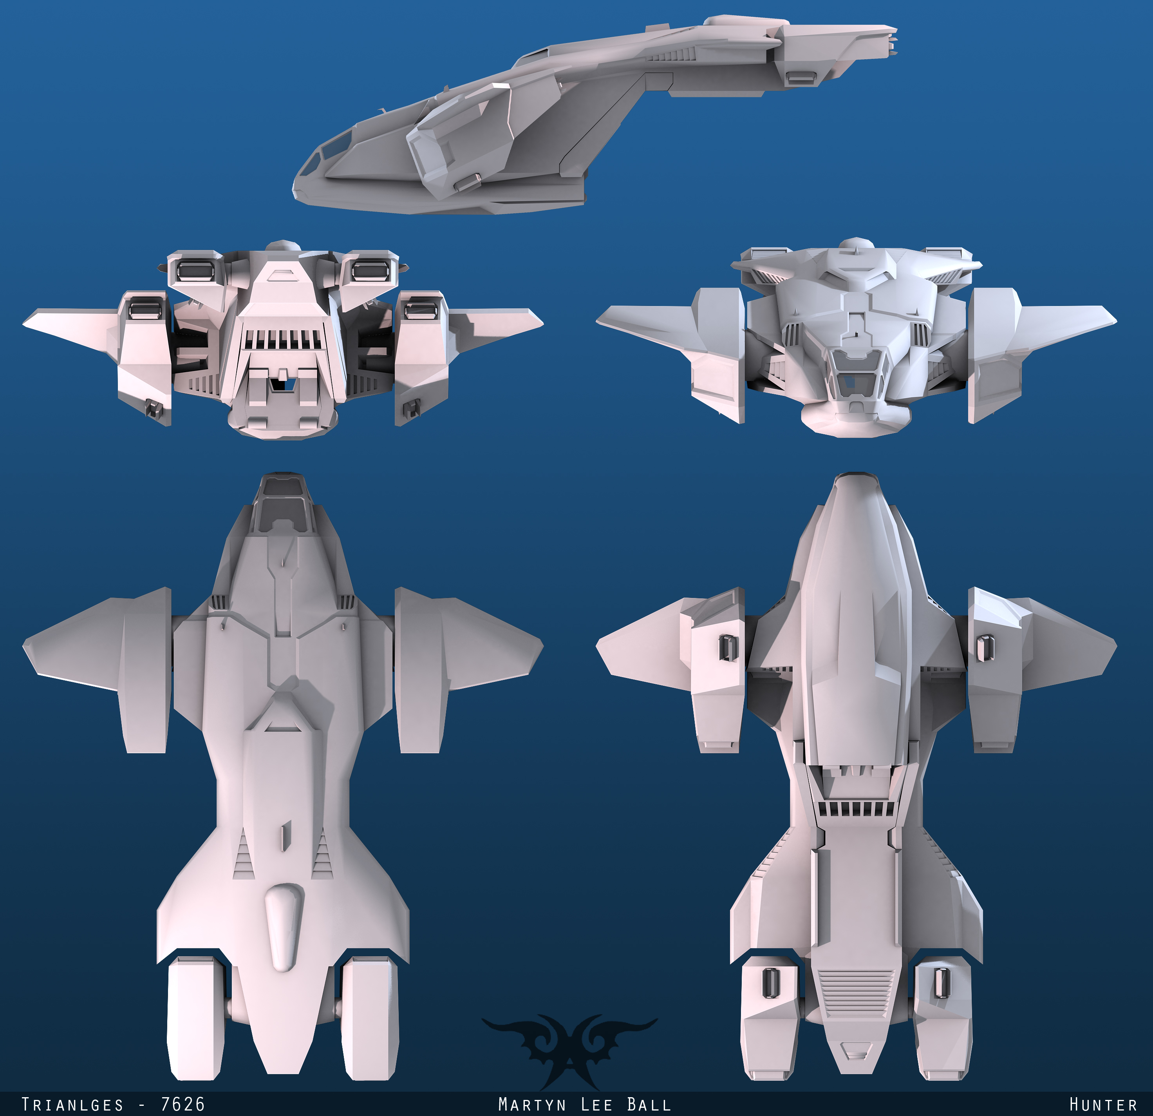

Asked if I could use his 3d model file for reference in creating scaled remote controlled pelican, he said yes!

On inspection of file
Can’t be used directly, made of all flat surfaces “folded” into 3d shape
Will use as reference source for dimensions

Similar Senior Design Project
Portable High Performance Model Aircraft
Information unavailable from Library
Last checked Oct 25 2011

Quad Tilt Rotor Air Craft    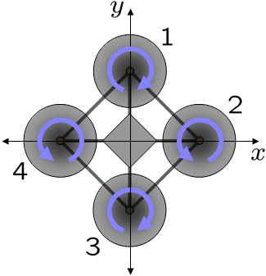  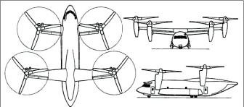  Quad Tilt Rotor Air Craft  Continued    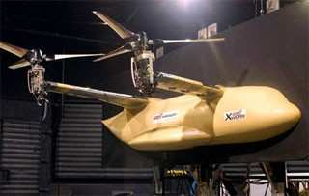 | http://en.wikipedia.org/wiki/Quadrotor  http://en.wikipedia.org/wiki/Bell_Boeing_Quad_TiltRotor  http://www.globalsecurity.org/military/systems/aircraft/qtr.htm  http://www.aero-news.net/index.cfm?do=main.textpost&id=82a6fd0d-af70-4dfd-a173-bb3f1ac52a57  Accessed Sept 2011  Comparison:  Four fixed rotors vs. four rotors that tilt to “airplane” position  Noted Features  - Two pairs of counter rotating rotors  - Very stable  - Large lift capacity  - Very maneuverable  - Combines speed and forward flight efficiency of airplane with VTOL of helicopter

appendix b – Component Research

Transmitters / Receivers  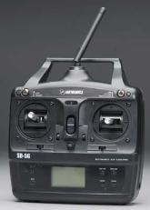  5 channel transmitter and receiver $99.99  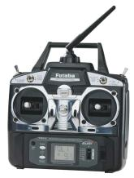  6 channel transmitter and receiver $219.99  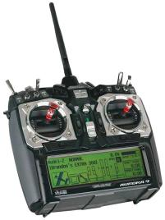  9 channel transmitter and receiver $429.99    9 channel transmitter and receiver $39.99 | Comments  Tower Hobbies  http://www3.towerhobbies.com/cgi-bin/wti0001p?&I=LXZHG0&P=7  http://www3.towerhobbies.com/cgi-bin/wti0095p?FVPROFIL=&FVSEARCH=+++LXPZT8+&search=Go  http://www3.towerhobbies.com/cgi-bin/wti0001p?&I=LXXCZ5&P=0  Hobby King  http://www.hobbyking.com/hobbyking/store/__8992__Turnigy_9X_9Ch_Transmitter_w_Module_8ch_Receiver_Mode_2_v2_Firmware_.html  Accessed Oct 2011

Servos  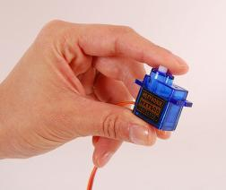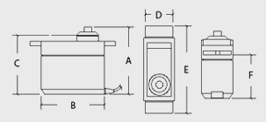  Weight (g) 9  Torque (kg) 1.6  Speed (Sec/60deg) 0.12  A(mm) 29  B(mm) 23  C(mm) 26  D(mm) 12  E(mm) 32  F(mm) 16  $2.69  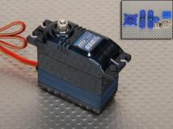  Weight (g) 52  Torque (kg) 10.6  Speed (Sec/60deg) 0.13  A(mm) 47  B(mm) 41  C(mm) 43  D(mm) 20  E(mm) 55  F(mm) 32  $17.92  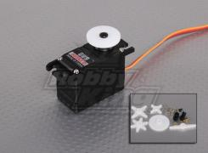    Weight (g) 30  Torque (kg) 6.6  Speed (Sec/60deg) 0.1  A(mm) 37  B(mm) 39  C(mm) 34  D(mm) 20  E(mm) 53  F(mm) 26  $11.18 | Comments  Hobby King  http://www.hobbyking.com/hobbyking/store/__662__HXT900_9g_1_6kg_12sec_Micro_Servo.html  http://www.hobbyking.com/hobbyking/store/__9441__Turnigy_620DMG_HS_High_Torque_Digital_Servo_MG_10_6kg_13sec_52g.html  http://www.hobbyking.com/hobbyking/store/__15514__GWS_S03N2_D_HP2BB_30g_0_10Sec_6_6kg_Digital_Servo.html  Accessed Oct 2011

Computer controller  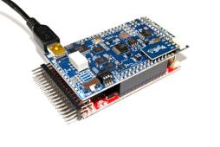  ArduPilot Mega $299.95  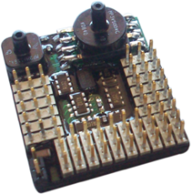  AttoPilot v3.0 AHRS IMU Complete Package  $3100.00 | DIY Drones / Udrones  http://diydrones.com/  http://www.udrones.com/product_p/expck1.htm  Accessed Oct 2011  Comments

Batteries    Spec.  Minimum Capacity: 2100mAh  Configuration: 3S1P / 11.1v / 3Cell  Constant Discharge: 35C  Peak Discharge (10sec): 45C  Pack Weight: 197g  Pack Size: 113 x 34 x 25mm  $14.99  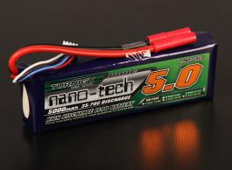  Spec.  Capacity: 5000mAh  Voltage: 3S1P / 3S Cell / 11.1V  Discharge: 35C Constant / 70C Burst  Weight: 409g (including wire, plug & case)  Dimensions: 150x49x26mm  $41.73 | Hobby King  http://www.hobbyking.com/hobbyking/store/__14978__Zippy_Flightmax_2100mAh_3S_35C_Lipo_Pack_USA_Warehouse_.html  http://www.hobbyking.com/hobbyking/store/__20739__Turnigy_nano_tech_5000mah_3S_35_70C_Lipo_Pack_USA_Warehouse_.html  Accessed Oct 2011  Comments

Wires and connectors and switches | Comments  In Store Visit needed!  Hobby Town USA

Motors / Ducted Fans
Hobby Partz
http://www.hobbypartz.com/88e-adf55-300l-kv4300.html

http://www.hobbypartz.com/88e-df30213-adf30-100-8000kv.html

Accessed Oct 2011

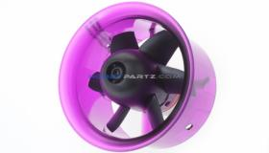

Product | KV | w/Motor | Weight(g) | w/EDF | Volts | Amps | Thurst(g) | Thrust(oz) | watt(W) | Efficiency(g/W) | Efficiency (W/oz)
ADF55-300L | 4300 | ADH-300L | 58 | ADF55 | 10.0 | 17.0 | 430 | 15.17 | 170.0 | 2.53 | 0.09
 |  |  |  |  | 11.1 | 18.0 | 470 | 16.58 | 199.8 | 2.35 | 0.08

$17.70

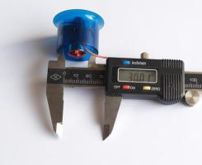

Product | KV | w/Motor | Weight(g) | w/EDF | Volts | Amps | Thurst(g) | Thrust(oz) | watt(W) | Efficiency(g/W) | Efficiency (W/oz)
ADF30-100 w/ 8000KV | 8000 | \ | 16 | ADF30 | 7.0 | 6.8 | 60 | 2.12 | 47.6 | 1.26 | 0.04
 |  |  |  |  | 7.5 | 7.4 | 68 | 2.40 | 55.5 | 1.23 | 0.04
 |  |  |  |  | 8.0 | 8.3 | 78 | 2.75 | 66.4 | 1.17 | 0.04
 |  |  |  |  | 8.5 | 8.8 | 84 | 2.96 | 74.8 | 1.12 | 0.04
 |  |  |  |  | 10.0 | 11.2 | 114 | 4.02 | 112.0 | 1.02 | 0.04
 |  |  |  |  | 11.1 | 12.6 | 132 | 4.66 | 139.9 | 0.94 | 0.03
 |  |  |  |  | 12.6 | 15.6 | 160 | 5.64 | 196.6 | 0.81 | 0.03
$23.70

Electronic Speed Controllers    30 amp ESC $20.00    40 amp ESC $38.49 | Hobby Partz  http://www.hobbypartz.com/07e04-proton-30a.html  http://www.hobbypartz.com/07e05-proton-40a.html  Accessed Oct 2011

Hardware  DIY  HOME DEPOT  LOWS  ….. | Comments  Needs TBD

Bass / Balsa Wood  Hobby Town USA | Comments  Needs TBD

Foam Parts
WE CUT FOAM
http://www.wecutfoam.com/
FOAM FACTORY
http://www.thefoamfactory.com/

Accessed Oct 2011

Telemetry System (testing)  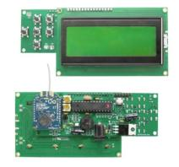  ArduStation $57.20  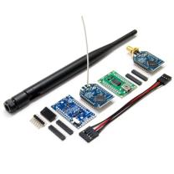  Xbee Telemetry Kit $150.00 | DIY Drones  http://store.diydrones.com/ArduStation_p/de-0001-01.htm  http://store.diydrones.com/Xbee_Telemetry_kit_p/kt-telemetry-xbee.htm  Accessed Oct 2011  Comments  Both kits designed to work with ArduPilot Mega

Appendix C -Cusomter survey

Customer Survey
Remote Controlled Vertical Take Off and Landing Aircraft

The project is to develop a scaled prototype remote controlled VTOL hybrid aircraft modeled after the Halo Pelican drop-ship. By answering the questions below you will help determine the relative importance of each feature. Please take a few minutes and answer.

How important is each of the following:
1= low importance 5= high importance Please circle your answers.

- Similarity of appearance to Halo Pelican Drop-Ship (not exact)

1(1) 2(1) 3(1) 4(5) 5(1) N/A() Avg.(3.44)

- VTOL ( vertical take-off and landing)

1() 2() 3() 4() 5(9) N/A() Avg.(5.00)

- Flight stability

1() 2() 3() 4(2) 5(7) N/A() Avg.(4.78)

- Low cost

1() 2(2) 3(4) 4(1) 5(3) N/A() Avg.(3.89)

- Safety and Indoor safe flight

1() 2() 3(2) 4(1) 5(5) N/A(1) Avg.(3.89)

- Legal to fly in the USA

1() 2() 3(3) 4(1) 5(4) N/A(1) Avg.(3.67)

- Simplicity of preflight setup

1() 2() 3(2) 4(3) 5(4) N/A() Avg.(4.22)

- Fitting into a trunk of midsize car, fully assembled

1() 2(2) 3(1) 4(4) 5(2) N/A() Avg.(3.67

- A known scale ratio (size only)

1() 2(4) 3(2) 4(3) 5() N/A() Avg.(2.89)

- Easy for one person to fly

1() 2() 3(1) 4(2) 5(6) N/A() Avg.(4.56)

- Inexpensive replacement parts

1() 2() 3(6) 4(4) 5() N/A() Avg.(2.78)

- Durability

1() 2() 3() 4(6) 5(3) N/A() Avg.(4.33)

- Easy to Assemble and maintain

1() 2() 3(1) 4(5) 5(3) N/A() Avg.(4.22)

- Please list any other specific features which you would like to see included on possible future models.

-never used something like this so I feel that ease of flight and durability are very important.
- Pin up girl painted on the front like the WWII planes
- Load capacity, what is it?

If not done in person or on a forum, please return via email to oltersm@mail.uc.edu
Thank You!

APPENDIX D – QFD

APPENDIX E – Schedual

Appednix f – Prototype Budget

Component / Materials | Forecasted Quantity | Total Forecasted Amount $ | Actual Quantity | Total Actual Amount $
Receiver / Transmitter | 1 | 300 | 1 | 300
Servos | 5+ | 100 | 4 | 45
Computer Controller | 1 | 500 | 1 | 450
Batteries | 8+ | 240 | 8
Wire / Connectors / Switches |  | 90
Motors / Ducted Fans | 16+ | 480 | 12
Electronic Speed Controllers | 8+ | 240 | 8
Hardware |  | 150
Bass / Balsa Wood |  | 400
Foam Parts |  | 2000
Telemetry System (testing) | 1 | 220 | 1
Miscellaneous | < 6% | 280
Total |  | $5,000

Appendix G – Glossery

Term | Definition
VTOL
ESC
Receiver
transmitter
Servo
Micro Controller
In progress
Will be finished for final

Appendix H – Design Drawings

Assembly Drawings

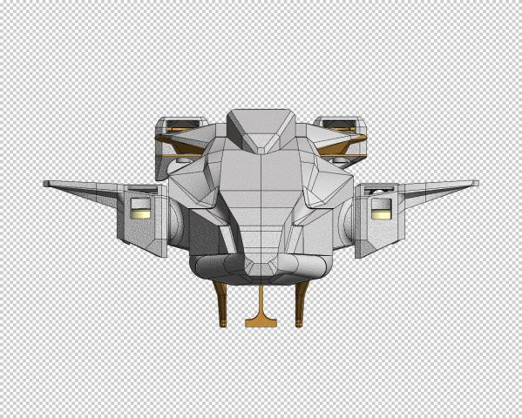

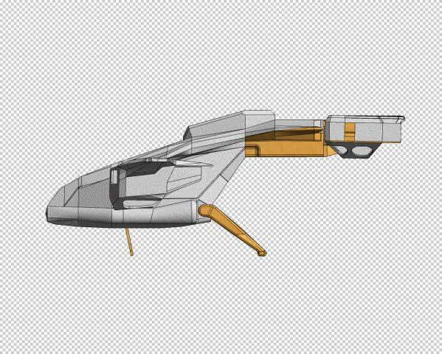

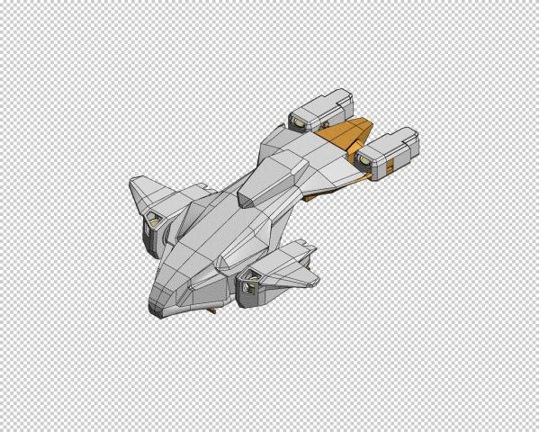

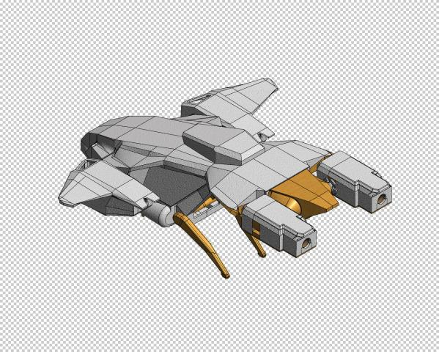

Part Drawings

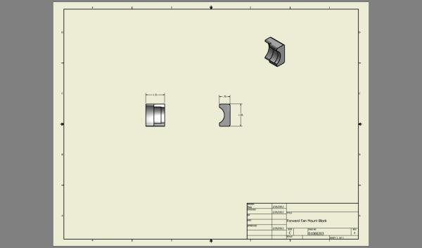

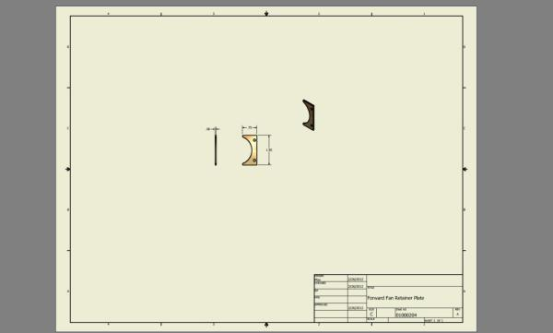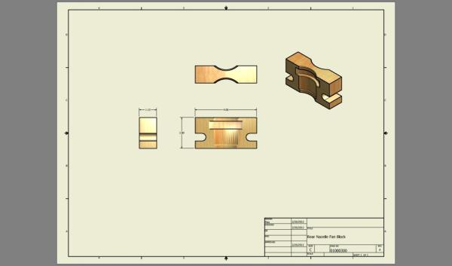

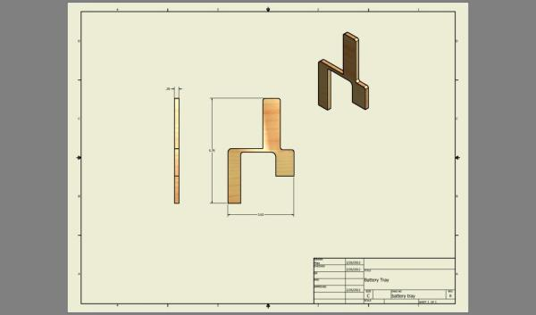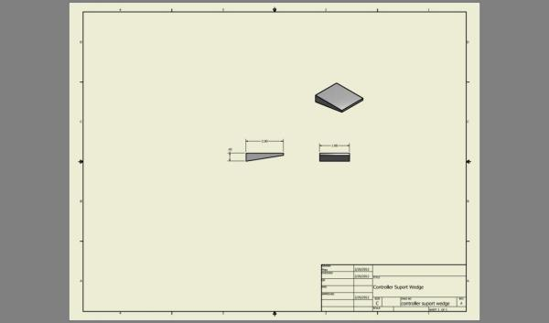

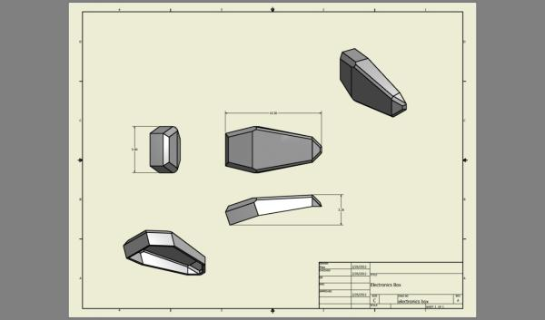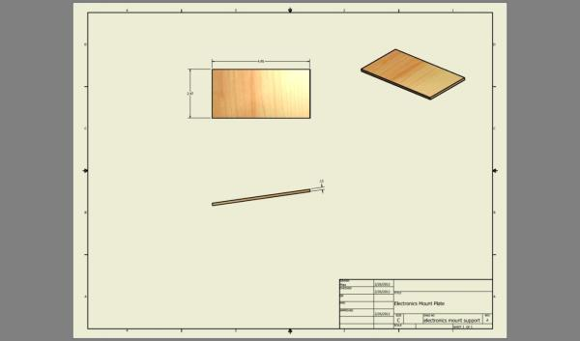

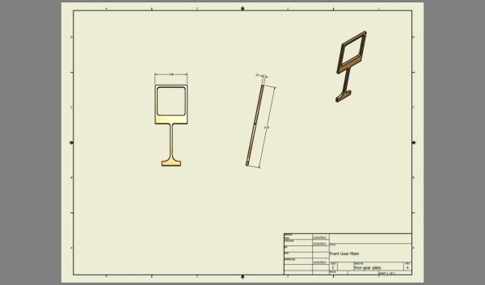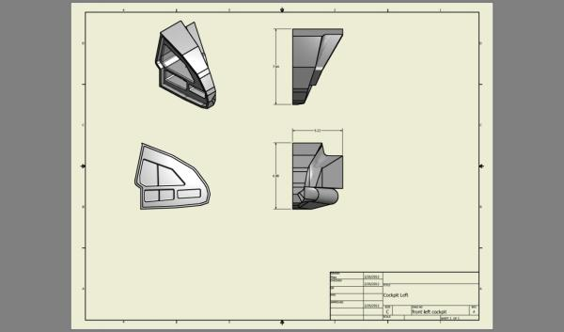

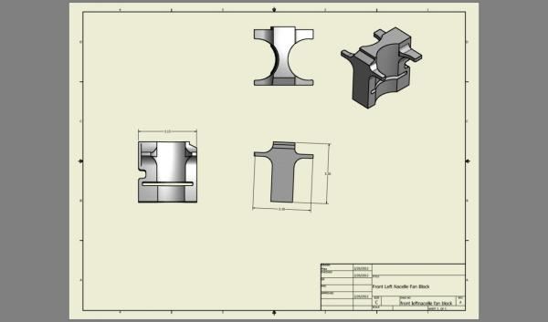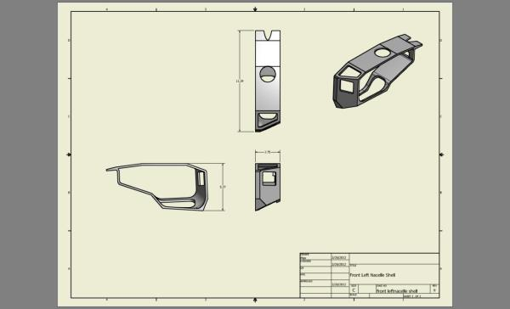

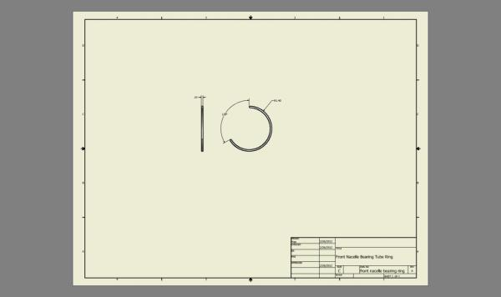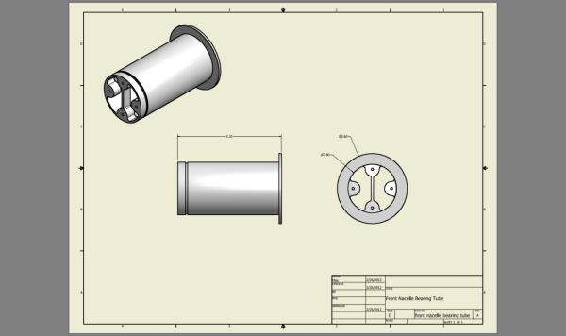

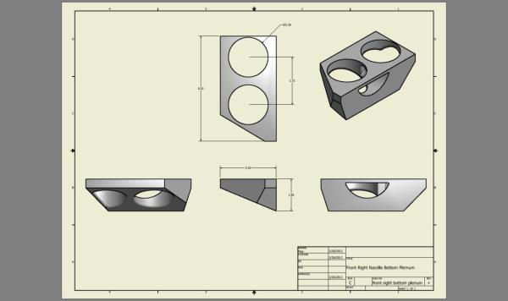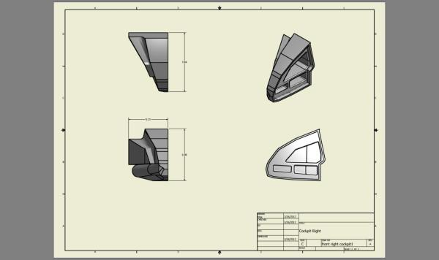

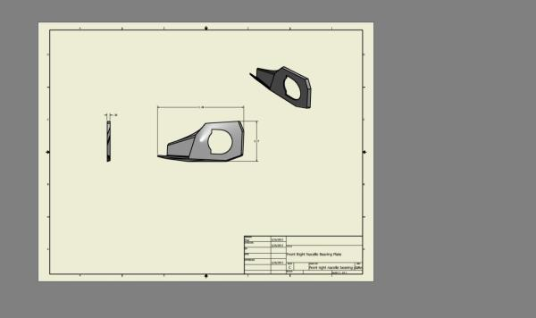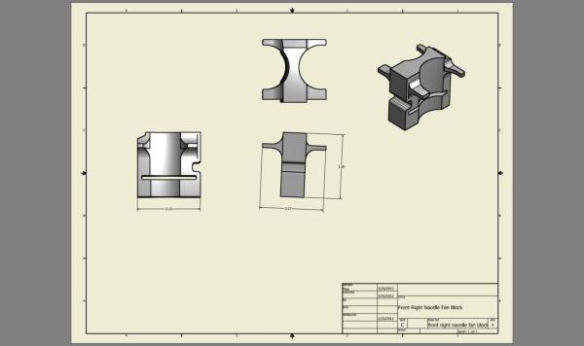

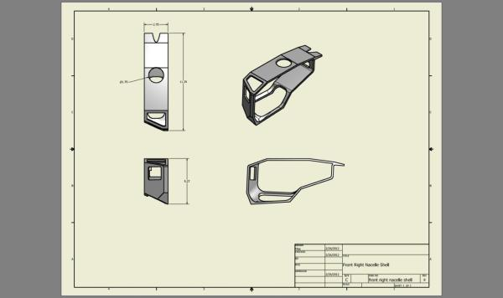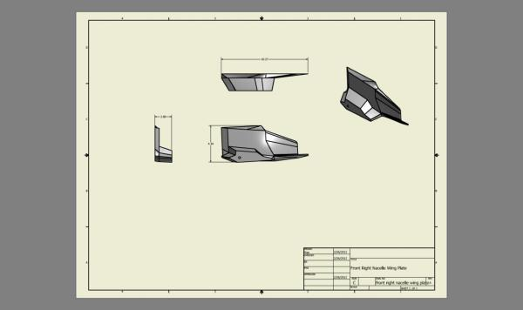

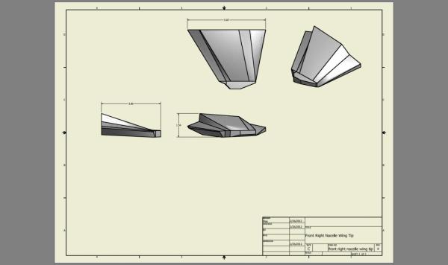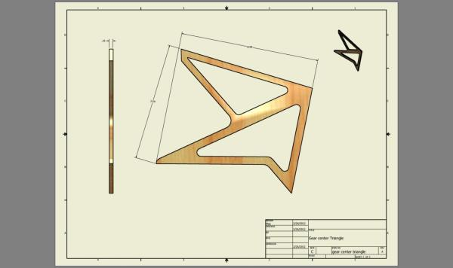

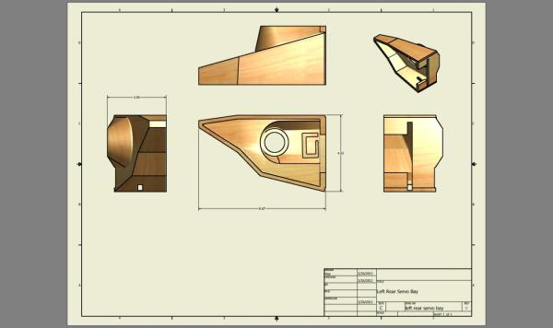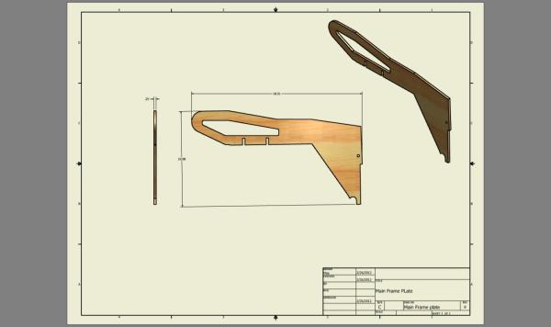

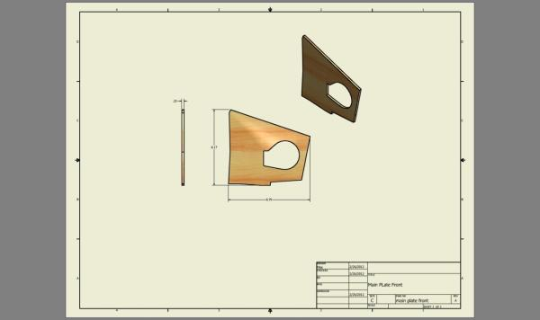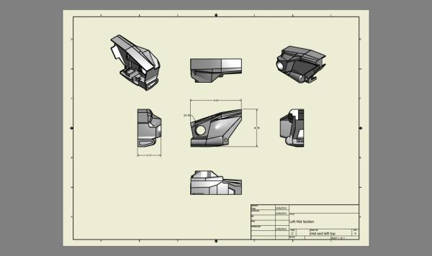

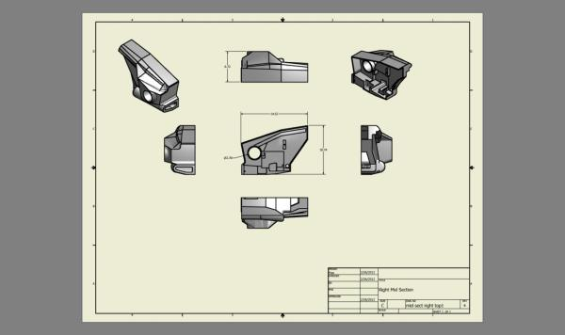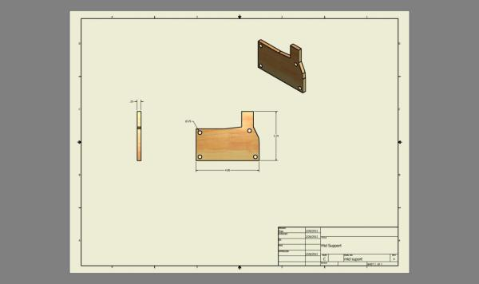

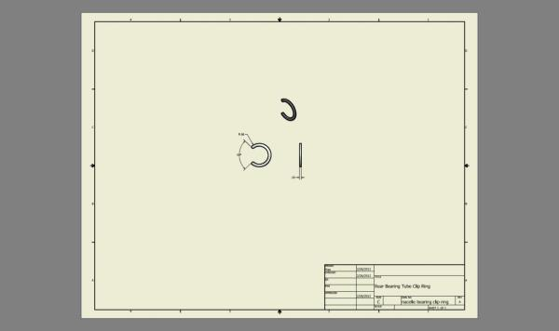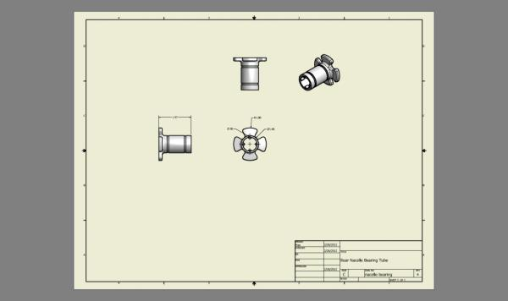

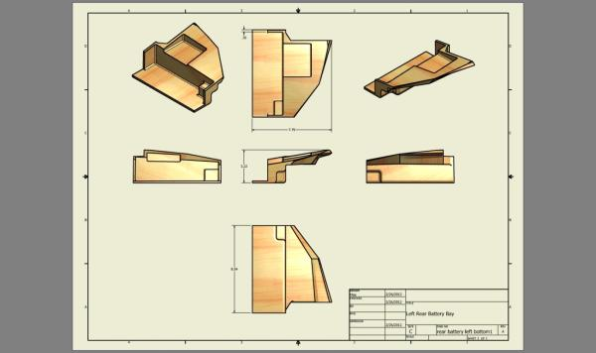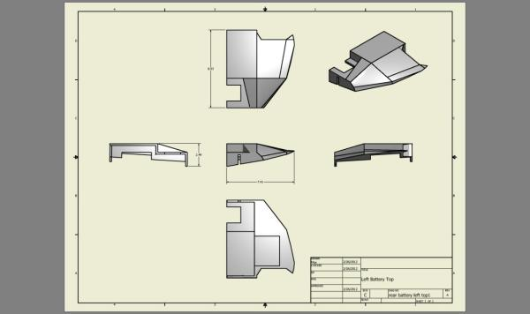

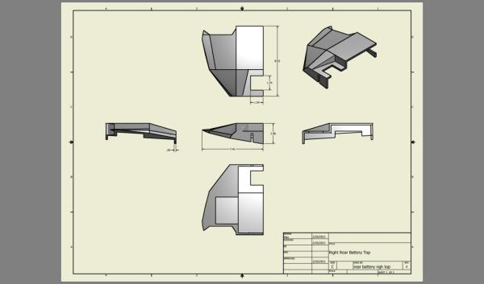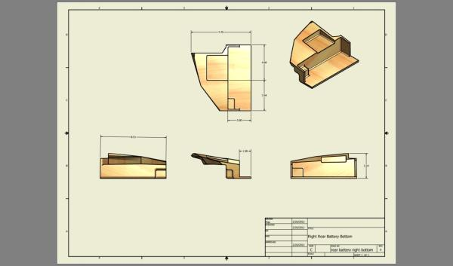

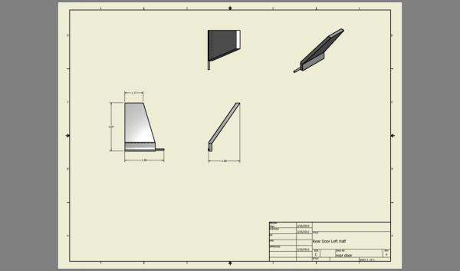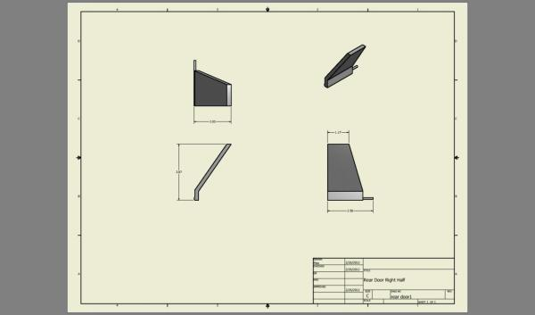

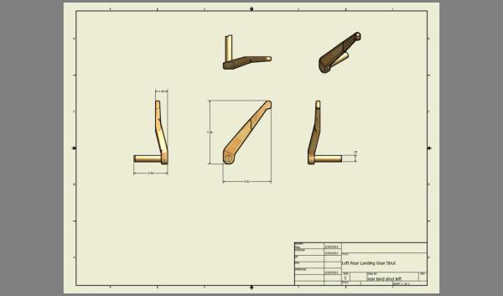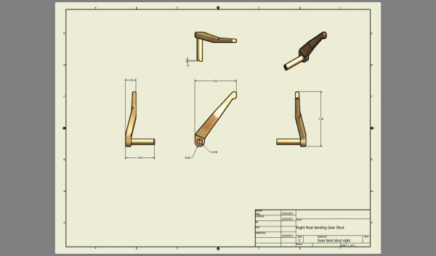

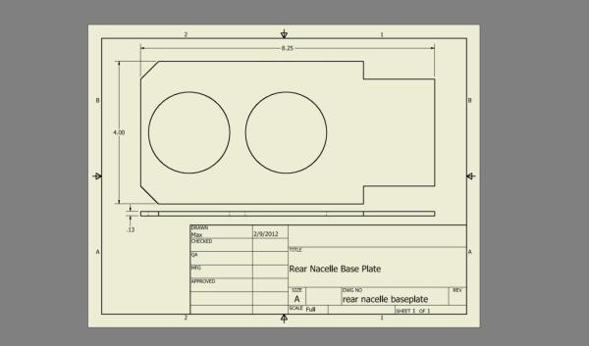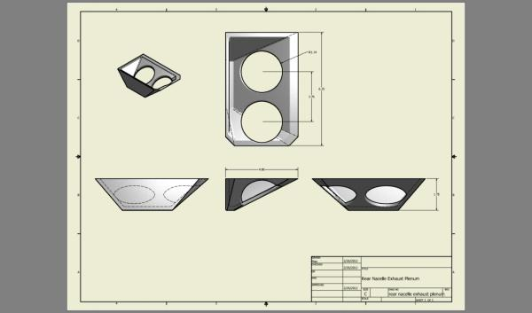

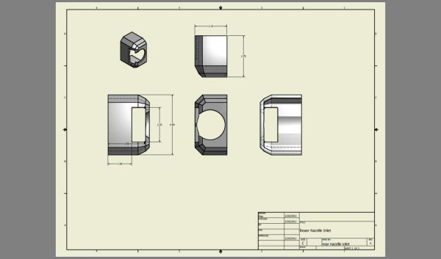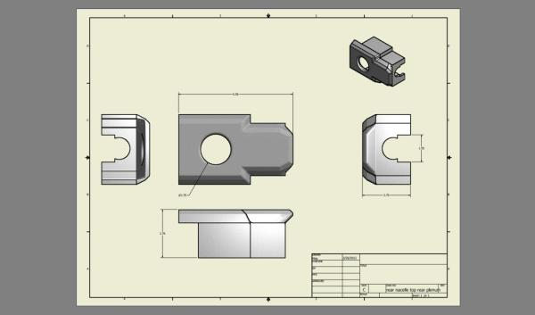

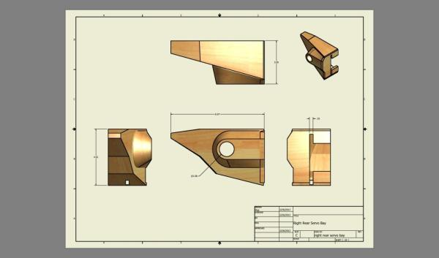

Appendix J – Design Analysis Reports

The following tables and images are from Autodesk Inventor’s stress analysis program.
Each report is a comprehensive summary of the analysis of the remote controlled hybrid aircraft as modeled in Inventor.

Simulation ~ On the Ground – Initial Design Iteration

Physical
Mass | 6.35927 lbmass
Area | 5756.65 in^2
Volume | 1013.49 in^3
Center of Gravity | x=3.45681 in  y=0.00121443 in  z=5.5855 in

Gravity
Load Type | Gravity
Vector X | 0.000 in/s^2
Vector Y | 0.000 in/s^2
Vector Z | -386.220 in/s^2

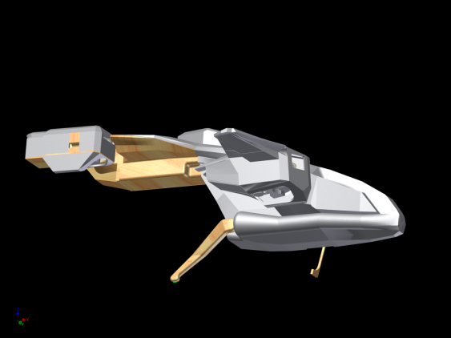

Reaction Force and Moment on Constraints
Constraint Name | Reaction Force |  | Reaction Moment
 | Magnitude | Component (X,Y,Z) | Magnitude | Component (X,Y,Z)
Fixed Constraint:1 | 1.62349 lbforce | 0.219526 lbforce | 0.273057 lbforce ft | 0.0032405 lbforce ft
 |  | -0.0453782 lbforce |  | -0.272539 lbforce ft
 |  | 1.60793 lbforce |  | -0.0164984 lbforce ft
Fixed Constraint:2 | 1.56729 lbforce | 0.0633363 lbforce | 0.270571 lbforce ft | 0.00351705 lbforce ft
 |  | -0.0167491 lbforce |  | -0.269938 lbforce ft
 |  | 1.56592 lbforce |  | 0.0181512 lbforce ft
Fixed Constraint:3 | 2.84789 lbforce | -0.845151 lbforce | 0.145799 lbforce ft | -0.00623594 lbforce ft
 |  | 0.0701345 lbforce |  | -0.144987 lbforce ft
 |  | 2.71869 lbforce |  | 0.0140463 lbforce ft

Result Summary
Name | Minimum | Maximum
Volume | 1013.51 in^3
Mass | 6.35917 lbmass
Von Mises Stress | 0.0000000114695 ksi | 3.55117 ksi
1st Principal Stress | -0.902564 ksi | 1.64366 ksi
3rd Principal Stress | -2.43173 ksi | 0.841613 ksi
Displacement | 0 in | 0.35265 in
Safety Factor | 0.816844 ul | 15 ul

Displacement
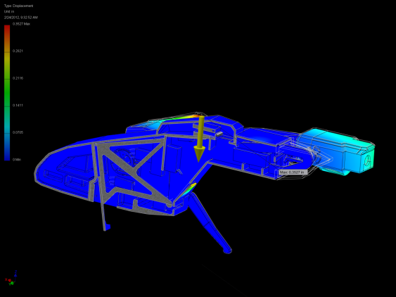
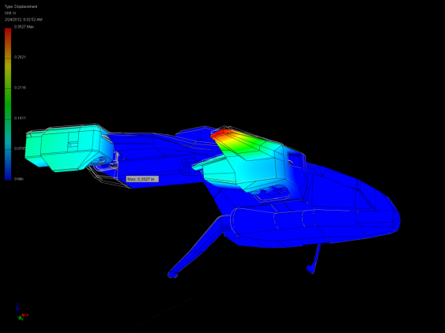

Safety Factor
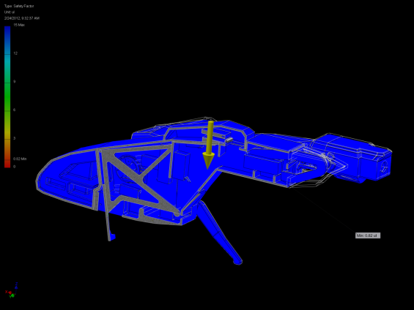
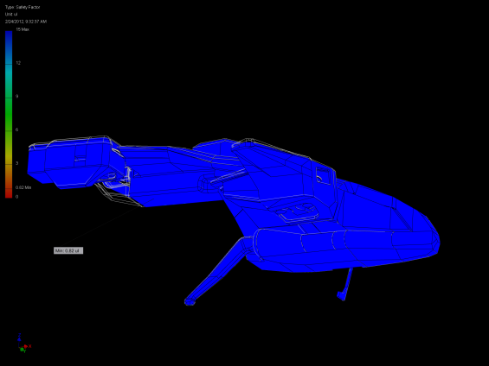

Simulation ~ On the Ground - Final

Physical
Mass | 6.34782 lbmass
Area | 5734.98 in^2
Volume | 1008.49 in^3

Gravity
Load Type | Gravity
Vector X | 0.000 in/s^2
Vector Y | 0.000 in/s^2
Vector Z | -386.220 in/s^2

Constraints
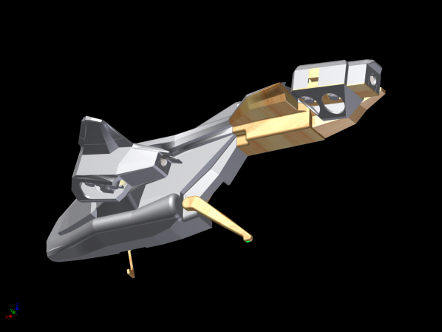
Fixed at the bottom of each landing gear strut

Reaction Force and Moment on Constraints
Constraint Name | Reaction Force |  | Reaction Moment
 | Magnitude | Component (X,Y,Z) | Magnitude | Component (X,Y,Z)
Fixed Constraint:1 | 2.43002 lbforce | 0.462618 lbforce | 0.388396 lbforce ft | -0.00065276 lbforce ft
 |  | 0.124658 lbforce |  | -0.387432 lbforce ft
 |  | 2.38232 lbforce |  | 0.027341 lbforce ft
Fixed Constraint:2 | 2.48805 lbforce | 0.52787 lbforce | 0.38531 lbforce ft | 0.00545976 lbforce ft
 |  | -0.147659 lbforce |  | -0.384005 lbforce ft
 |  | 2.42692 lbforce |  | -0.0312041 lbforce ft
Fixed Constraint:3 | 1.81047 lbforce | -0.9829 lbforce | 0.201818 lbforce ft | -0.00255826 lbforce ft
 |  | 0.0335783 lbforce |  | -0.201801 lbforce ft
 |  | 1.52005 lbforce |  | 0 lbforce ft

Result Summary
Name | Minimum | Maximum
Volume | 1008.5 in^3
Mass | 6.34773 lbmass
Von Mises Stress | 0.00000000711608 ksi | 1.79663 ksi
1st Principal Stress | -0.432901 ksi | 1.37769 ksi
3rd Principal Stress | -1.37815 ksi | 0.301354 ksi
Displacement | 0 in | 0.337162 in
Safety Factor | 3.25575 ul | 15 ul

Displacement
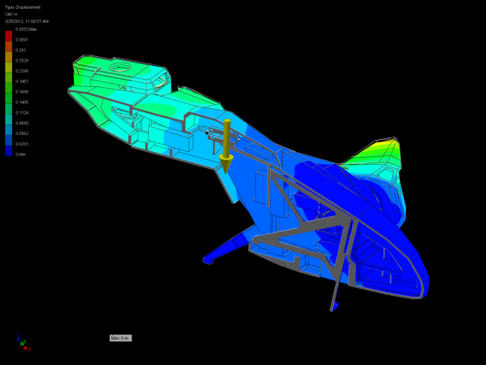

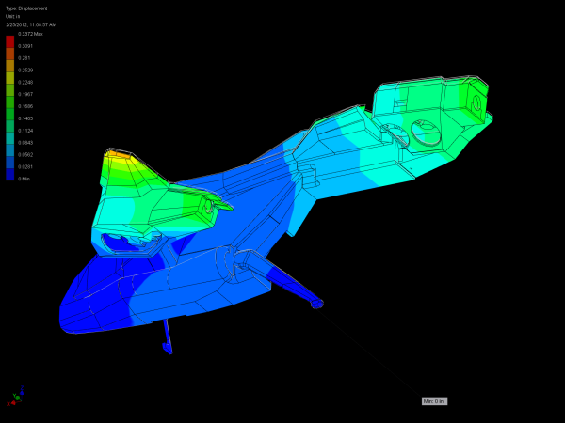

Safety Factor
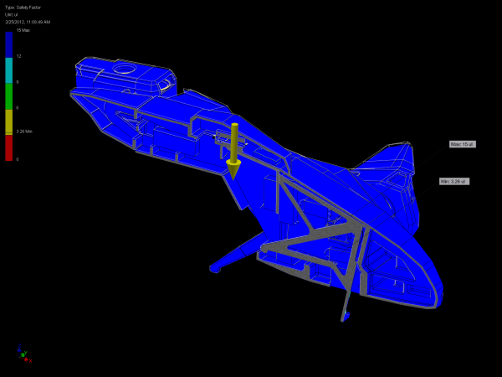
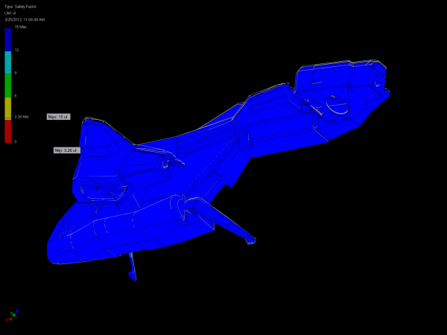

Simulation ~ Vertical Acceleratio

Gravity
Load Type | Gravity
Vector X | 0.000 in/s^2
Vector Y | 0.000 in/s^2
Vector Z | -463.464 in/s^2

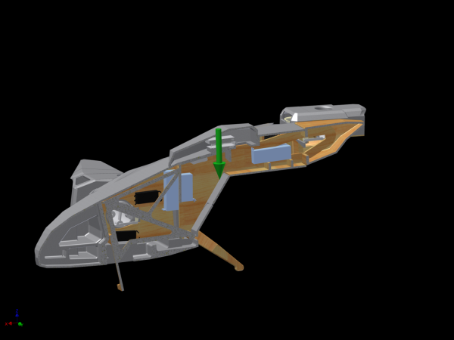

Constraints
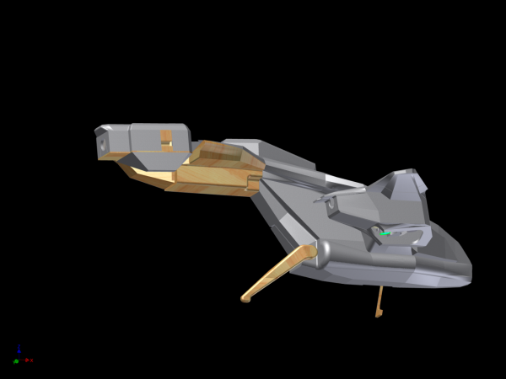
Fixed at the bottom surface of each of the 8 fan motors

Reaction Force and Moment on Constraints
Constraint Name | Reaction Force |  | Reaction Moment
 | Magnitude | Component (X,Y,Z) | Magnitude | Component (X,Y,Z)
Fixed Constraint:1 | 0.615586 lbforce | -0.0744623 lbforce | 0.0595662 lbforce ft | -0.0577822 lbforce ft
 |  | 0.185862 lbforce |  | 0.00479717 lbforce ft
 |  | 0.582114 lbforce |  | -0.0136502 lbforce ft
Fixed Constraint:2 | 0.607294 lbforce | 0.236372 lbforce | 0.0185449 lbforce ft | 0.00485668 lbforce ft
 |  | -0.182234 lbforce |  | 0.00843279 lbforce ft
 |  | 0.528891 lbforce |  | -0.0157866 lbforce ft
Fixed Constraint:3 | 0.50412 lbforce | -0.0727183 lbforce | 0.0228787 lbforce ft | 0.0113407 lbforce ft
 |  | 0.0567238 lbforce |  | 0.0125116 lbforce ft
 |  | 0.495612 lbforce |  | -0.0154364 lbforce ft
Fixed Constraint:4 | 0.57147 lbforce | 0.195598 lbforce | 0.0396492 lbforce ft | 0.0343477 lbforce ft
 |  | -0.0343389 lbforce |  | 0.0143982 lbforce ft
 |  | 0.535854 lbforce |  | -0.0136009 lbforce ft
Fixed Constraint:5 | 5.12436 lbforce | -1.07504 lbforce | 0.21788 lbforce ft | -0.0616076 lbforce ft
 |  | 0.205847 lbforce |  | -0.040712 lbforce ft
 |  | 5.0061 lbforce |  | -0.204985 lbforce ft
Fixed Constraint:6 | 2.50838 lbforce | 0.96399 lbforce | 0.103185 lbforce ft | 0.0347634 lbforce ft
 |  | -0.726804 lbforce |  | 0.038228 lbforce ft
 |  | -2.19874 lbforce |  | 0.0893153 lbforce ft
Fixed Constraint:7 | 5.07557 lbforce | -0.406045 lbforce | 0.211844 lbforce ft | -0.0709836 lbforce ft
 |  | 0.680801 lbforce |  | 0.0256146 lbforce ft
 |  | 5.01329 lbforce |  | -0.197948 lbforce ft
Fixed Constraint:8 | 2.35854 lbforce | 0.225419 lbforce | 0.100078 lbforce ft | -0.000810186 lbforce ft
 |  | -0.185856 lbforce |  | -0.0248021 lbforce ft
 |  | -2.34038 lbforce |  | 0.0969525 lbforce ft

Result Summary
Name | Minimum | Maximum
Volume | 1008.52 in^3
Mass | 6.34773 lbmass
Von Mises Stress | 0.000000011077 ksi | 4.16652 ksi
1st Principal Stress | -0.848802 ksi | 4.41169 ksi
3rd Principal Stress | -3.97507 ksi | 0.896579 ksi
Displacement | 0 in | 0.455989 in
Safety Factor | 2.41643 ul | 15 ul

Displacement
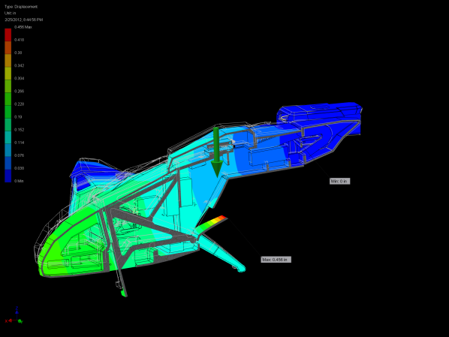
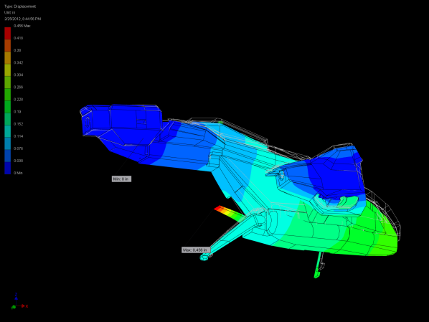

Safety Factor
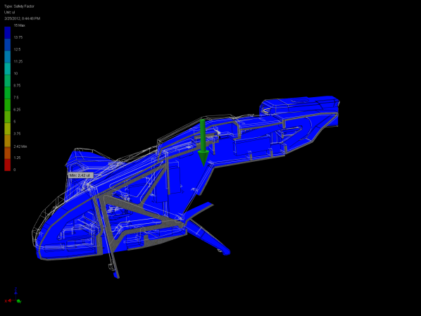
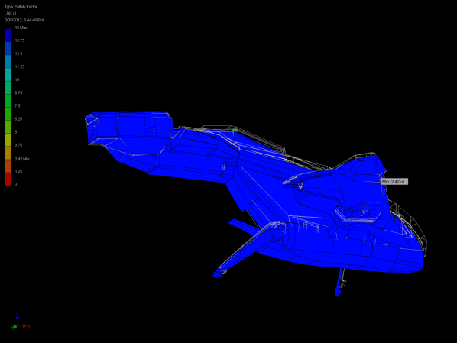

Simulation ~ Simple Impact

Gravity
Load Type | Gravity
Vector X | 0.000 in/s^2
Vector Y | 0.000 in/s^2
Vector Z | -1931.100 in/s^2

Selected Face(s)

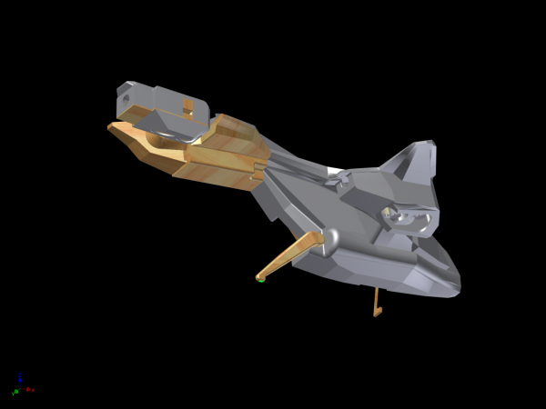
Fixed at bottom of each landing gear strut

Reaction Force and Moment on Constraints
Constraint Name | Reaction Force |  | Reaction Moment
 | Magnitude | Component (X,Y,Z) | Magnitude | Component (X,Y,Z)
Fixed Constraint:1 | 11.7105 lbforce | 2.36778 lbforce | 1.9195 lbforce ft | -0.00602157 lbforce ft
 |  | 0.626123 lbforce |  | -1.91517 lbforce ft
 |  | 11.4515 lbforce |  | 0.128708 lbforce ft
Fixed Constraint:2 | 11.9357 lbforce | 2.58095 lbforce | 1.89368 lbforce ft | 0.0182501 lbforce ft
 |  | -0.617149 lbforce |  | -1.88811 lbforce ft
 |  | 11.637 lbforce |  | -0.143958 lbforce ft
Fixed Constraint:3 | 9.75188 lbforce | -5.129 lbforce | 1.0452 lbforce ft | -0.00379194 lbforce ft
 |  | 0 lbforce |  | -1.04504 lbforce ft
 |  | 8.29413 lbforce |  | 0.0177892 lbforce ft

Result Summary
Name | Minimum | Maximum
Volume | 1008.5 in^3
Mass | 6.34773 lbmass
Von Mises Stress | 0.0000000339333 ksi | 10.1536 ksi
1st Principal Stress | -1.44549 ksi | 7.94926 ksi
3rd Principal Stress | -8.78712 ksi | 1.49894 ksi
Displacement | 0 in | 1.52468 in
Safety Factor | 0.57609 ul | 15 ul

Displacement
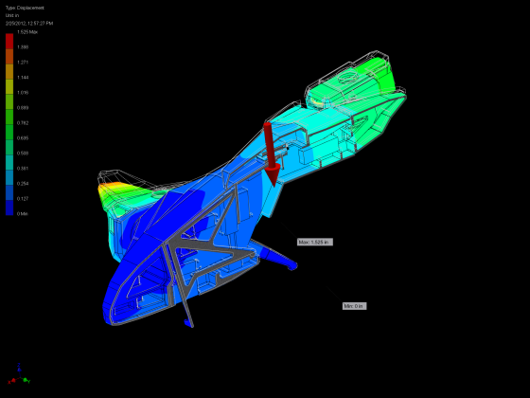
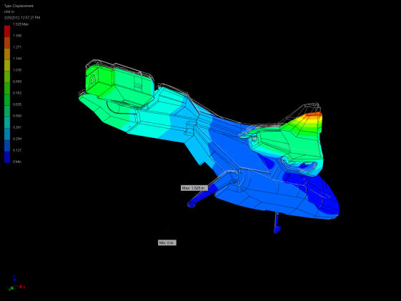

Safety Factor
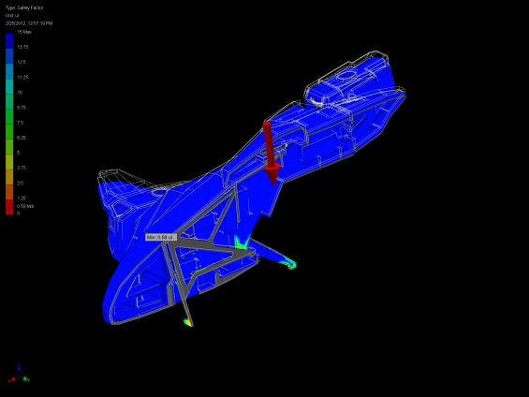
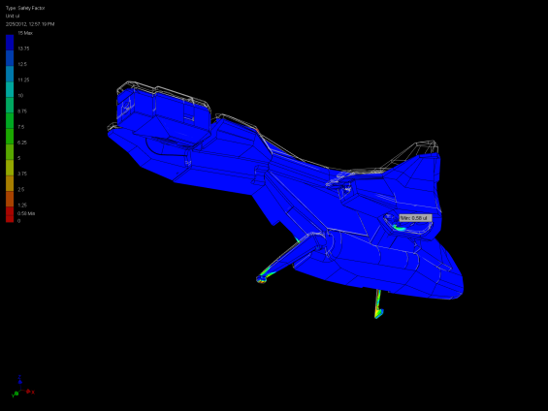
The weakest point is the landing gear struts, all other areas have safety factor of 1.25 or higher

Appendix K – Controler

Appendix L – Alternative Selection

Appendix M – Formulas Used

Estimation of vehicle mass prior to detailed modeling

Item | Density
 | Kg/M^3
Foam | 16
Balsa Wood | 128
Plastic | 1100

$$1) Vehicle Mass Estimate=({(F}_{sbv}*D_{main})*.01+{(F}_{sbv}*D_{sec})*.005+(F_{sbv}*D_{third})*.00005)/4$$

((Fuselage Scaled box volume*density of main material)*.01+(Fuselage Scaled box volume*density of second material)*.005+(Fuselage Scaled box volume*density of third material)*.00005)/4

Comparison of estimated mass to modeled mass
% diff
Post model Confirmation
F=ma

e | f | g | h | i | j | k
estimated misc mass | lift force | Sum Mass | Gravity force | Sum Forces | Acceleration vertical
 |  |  | Weight of prototype |  | (f=ma) or (a=f/m) | % diff Mass esti vs modeld
Kg | newtons | Kg | newtons | newtons | g's | %
0.2 | 31.4 | =2.65+E9 | =G9*9.81 | =F9-H9 | =I9/G9 | =(G9-2.8)/2.8*100

Will it lift off?
Pre Model Estimate used to determine
F=ma

estimated misc mass |  | lift force | Sum Mass |  | Gravity force |  | Sum Forces |  | Acceleration vertical |  |  | actual maximum lift force |  | emergancy power availible |  | emercncy
 |  |  |  |  | Weight of prototype |  |  |  | (f=ma) or (a=f/m) | % diff Mass esti vs modeld |  |  |  | lift force |  | peak acceleration
Kg |  | newtons | Kg |  | newtons |  | newtons |  | meters/sec^2 | % |  | newtons |  | newtons |  | g
0.2 |  | 31.4 | 3.08 |  | 30.2148 |  | 1.1772 |  | 0.382207792 | 10 |  | 36.8856 |  | 5.4936 |  | 0.220779221
0.25 |  | 31.4 | 3.13 |  | 30.7053 |  | 0.6867 |  | 0.219392971 | 11.78571429 |  | 36.8856 |  | 5.4936 |  | 0.201277955
0.3 |  | 31.4 | 3.18 |  | 31.1958 |  | 0.1962 |  | 0.061698113 | 13.57142857 |  | 36.8856 |  | 5.4936 |  | 0.182389937
 | 0.35 |  |  | 31.4 |  | 3.23 |  | 31.6863 |  |  | -0.2943 |  | -0.091114551 |  | 15.35714286 |  | 36.8856 |  | 5.4936 | 0.164086687
 | 0.4 |  |  | 31.4 |  | 3.28 |  | 32.1768 |  |  | -0.7848 |  | -0.239268293 |  | 17.14285714 |  | 36.8856 |  | 5.4936 | 0.146341463
 | 0.45 |  |  | 31.4 |  | 3.33 |  | 32.6673 |  |  | -1.2753 |  | -0.382972973 |  | 18.92857143 |  | 36.8856 |  | 5.4936 | 0.129129129

Figure 22
Figure 23

e | f | g | h | i | j | k | l | m | N
estimated misc mass | lift force | Sum Mass | Gravity force | Sum Forces | Acceleration vertical |  | actual maximum lift force | emergancy power availible | emercncy
 |  |  | Weight of prototype |  | (f=ma) or (a=f/m) | % diff Mass esti vs modeld |  | lift force | peak acceleration
Kg | newtons | Kg | newtons | newtons | meters/sec^2 | % | newtons | newtons | g
0.2 | =0.4*9.81*8 | =2.88+E9 | =G9*9.81 | =F9-H9 | =(I9/G9) | =(G9-2.8)/2.8*100 | =0.47*9.81*8 | =L9-F9 | =((L9-H9)/G9)/9.81

Impact force

Vehical mass | drop height | velecity at impact | FΔt or Δp | initial impact time | Impact Force | Impact acceleration
Kg | meter | m/s | N*s | seconds | Newton | g's
3 | 0.5 | 3.13 | -9.396 | 0.1 | -93.96 | 3.19

FEA deflection (1) | new impact time | Impact Force | Impact acceleration | F.E.A Min Saftey Factor(2) | Recommended Saftey Factor | Satisfactory(3)
meter | seconds | Newton | g's | ~ | ~ | yes / no
0.1 | 0.06 | -147.15 | 5.00 | 0.58 | 2 | no

1) Maximum Deflection in entire assembly is @ front nacelle rotating "freely" (un-powered state) divided by 2 for range of motion limit
2) FEA Calculates as non-mechanism; FEA deflection not true
3) Landing gear is only part that fails, could be reinforced easily

c | d | e | f | g | h | i | j | k | l | m | n | o | P
Vehical mass | drop height | velecity at impact | FΔt or Δp | initial impact time | Impact Force | Impact acceleration | FEA deflection (1) | new impact time | Impact Force | Impact acceleration | F.E.A Min Saftey Factor(2) | Recommended Saftey Factor | Satisfactory(3)
Kg | meter | m/s | N*s | seconds | Newton | g's | meter | seconds | Newton | g's | ~ | ~ | yes / no
3 | 0.5 | =SQRT(2*9.81*D7) | =C7*(0-E7) | 0.1 | =F7/G7 | =($E7/G7)/9.81 | 0.1 | =J7/(E7/2) | =$F7/K7 | =($E7/K7)/9.81 | 0.58 | 2 | =IF(O7<=N7,"yes","no")

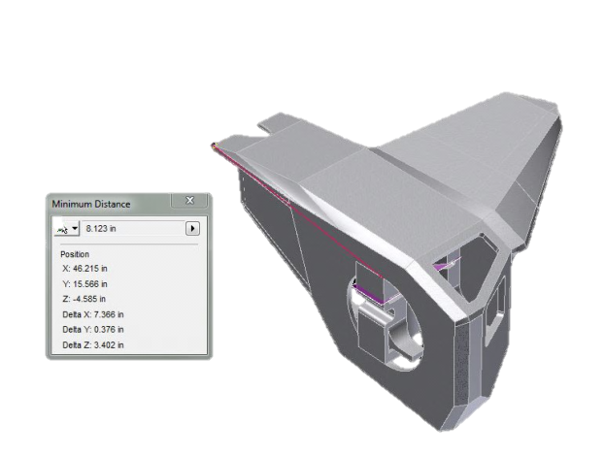

Nacelle torque

$$2) Nacelle Torque=\left(Force of gravity @ CG\right)*Perpindicular Distance$$

Initial positions
5g acceleration

1.5 in-lbs torque no torque
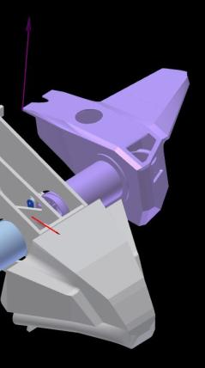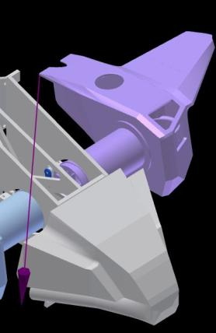

Final Positions
5g acceleration

1.5 in-lbs torque no torque
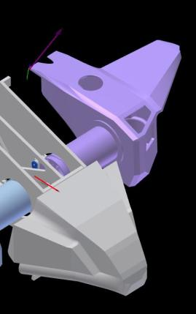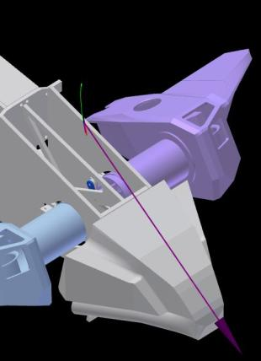

With torque the nacelle is still accelerating upwards

0.00000 | 0.00000
0.00010 | 0.08221
0.00020 | 0.16441
0.00030 | 0.24662
0.00040 | 0.32882
0.00050 | 0.41103
0.00060 | 0.49323
0.00070 | 0.57543
0.00080 | 0.65764
0.00090 | 0.73984
0.00100 | 0.82204
0.00110 | 0.90424
0.00120 | 0.98643
0.00130 | 1.06863
0.00140 | 1.15082
0.00150 | 1.23301
0.00160 | 1.31520
0.00170 | 1.39739
0.00180 | 1.47957
0.00190 | 1.56175
0.00200 | 1.64393
0.00210 | 1.72611
0.00220 | 1.80828
0.00230 | 1.89045
0.00240 | 1.97262
0.00250 | 2.05478

Without torque the nacelle accelerates downward

Time ( s ) | V (Trace:3) ( in/s )
0.00000 | 0.00000
0.00100 | -1.90739
0.00200 | -3.81444
0.00300 | -5.72082
0.00400 | -7.62618
0.00500 | -9.53020
0.00600 | -11.43253
0.00700 | -13.33283
0.00800 | -15.23076
0.00900 | -17.12600
0.01000 | -19.01810
0.01100 | -20.90690
0.01200 | -22.79190
0.01300 | -24.67280
0.01400 | -26.54920
0.01500 | -28.42080
0.01600 | -30.28722
0.01700 | -32.14810
0.01800 | -34.00310
0.01900 | -35.85180
0.02000 | -37.69380
0.02100 | -39.52880
0.02200 | -41.35638
0.02300 | -43.17620
0.02400 | -44.98780
0.02500 | -46.79080

Appendix N – Bill Of Matterial

Item | Part Number | QTY
1 | front left nacelle bearing plate | 1
2 | front leftnacelle shell | 1
3 | front leftnacelle wing plate | 1
4 | front leftnacelle wing tip | 1
5 | front leftnacelle fan block | 1
6 | 01000007 | 8
7 | 01000203 | 4
8 | front right nacelle bearing plate | 1
9 | front right nacelle shell | 1
10 | front right nacelle wing plate | 1
11 | front right nacelle wing tip | 1
12 | front right nacelle fan block | 1
13 | front nacelle bearing ring | 2
14 | front nacelle bearing tube | 2
15 | mid sect left top | 1
16 | mid sect right top1 | 1
17 | front left cockpit | 1
18 | front right cockpit1 | 1
19 | right rear servo bay | 1
20 | nacelle bearing | 2
21 | nacelle bearing clip ring | 4
22 | rear battery right bottom | 1
23 | rear battery righ top | 1
24 | rear battery left top1 | 1
25 | 01000200 | 3
26 | 01000204 | 3
27 | 01000300 | 2
28 | rear nacelle baseplate | 2
29 | rear nacelle exhaust plenum | 2
30 | rear nacelle inlet | 2
31 | rear nacelle top rear plenum | 2
32 | Main Frame plate | 2
33 | rear land strut left | 1
34 | rear land strut right | 1
35 | 1.6am battery | 4
36 | 9gram servo | 4
37 | mid suport | 2
38 | 01000015 | 4
39 | 01000016 | 4
40 | electronics box | 1
41 | electronics mount support | 1
42 | 30ampESC | 4
43 | wireless telematry module | 1
44 | receiver | 1
45 | auto pilot top | 1
46 | auto pilot | 1
47 | battery tray | 4
48 | rear battery left bottom1 | 1
49 | left rear servo bay | 1
50 | 55mm fan motor | 8
51 | controller suport wedge | 1
52 | main plate front | 2
53 | fron gear plate | 1
54 | gear center triangle | 1
55 | front gear servo arm | 4
56 | front nacelle servo link bar | 2
57 | rear nacelle link bar | 2
58 | rear door | 1
59 | rear door1 | 1

Appendix P – Air Flow Testing

